**Kahns algorithm**

1. 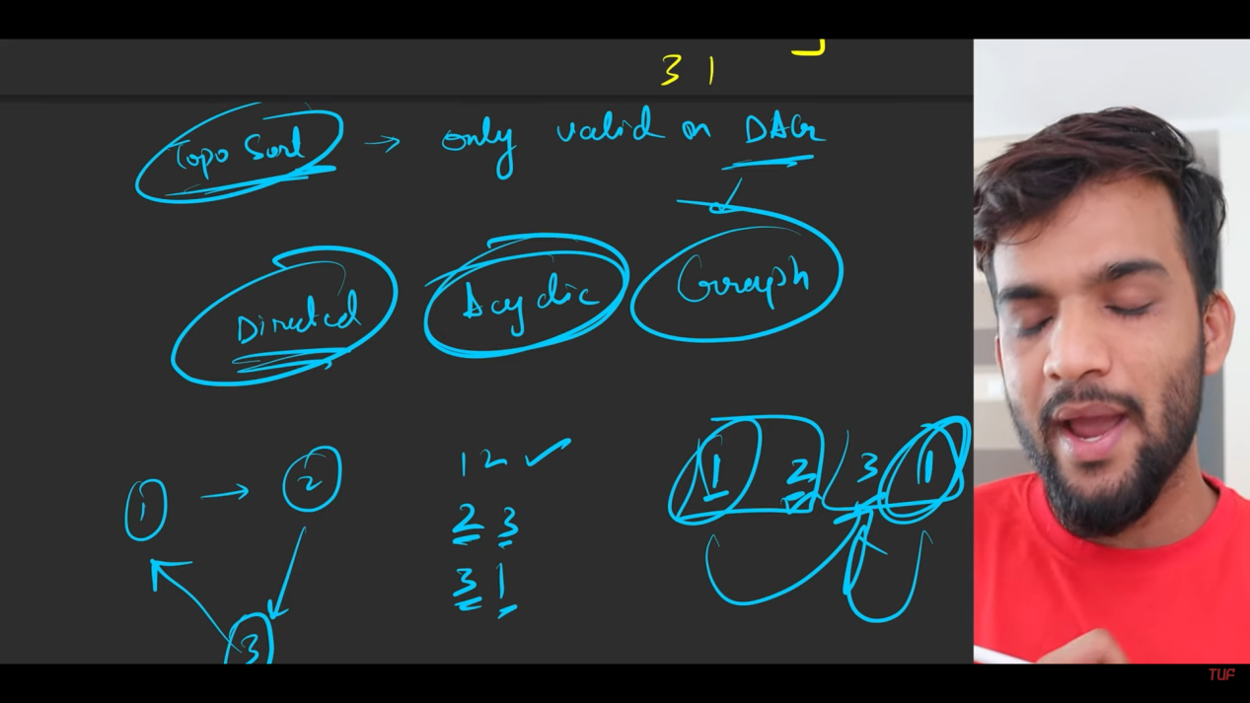
2. Topo sort is valid only when there is DAGs
3. Previously we solved topo sort using dfs technique and stack. Now it is time for BFS and queue.
4. 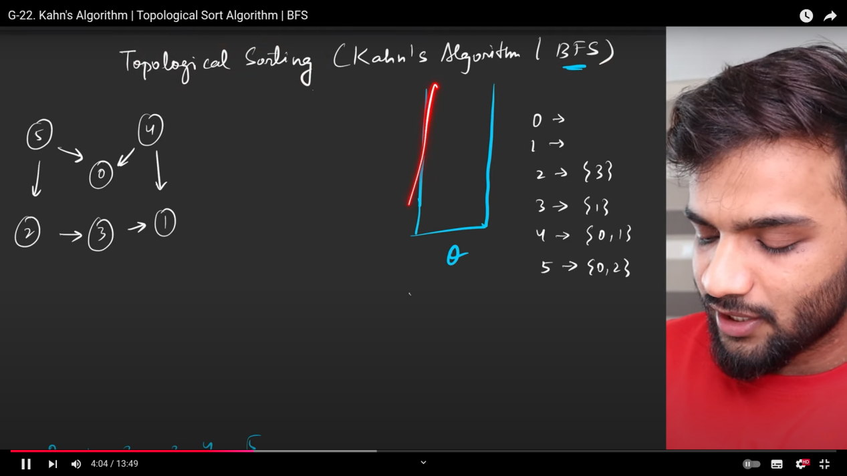
5. 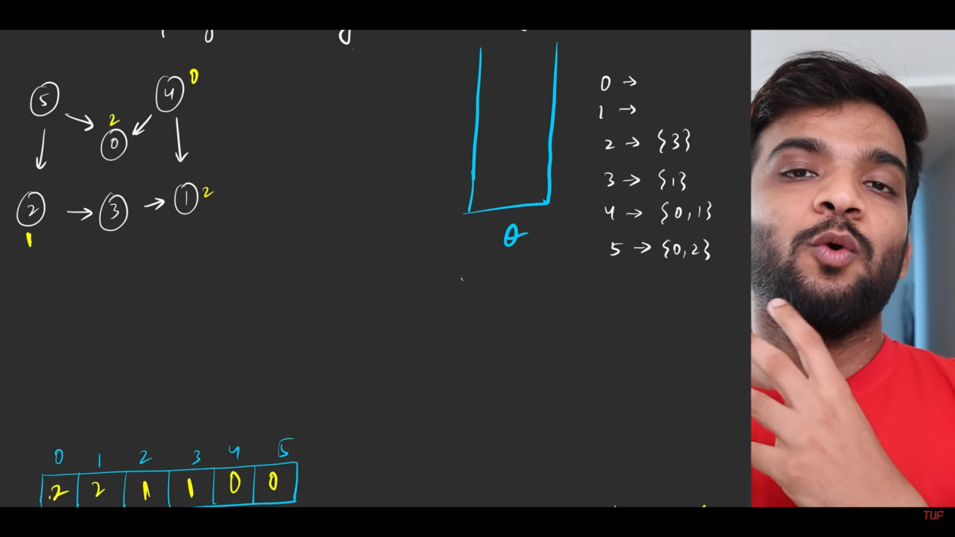

The below array is used for indegree of each and every node.

1. After calculating the indegree of each and every node:
   1. Insert the nodes with the indegree 0 to the queue.
   2. So from the inserted nodes of the queue, to which all the nodes the directed edges is going. So for all those nodes indegree has to be subtracted by one.
   3. Then check the indgree of the outgoing edges to the nodes, if the outgoing edge to node became the zero indegree, then add it into the queue. Else do not add it. Means the node still has the many incoming edges with me.
   4. While taking out the entry from the queue, add to the returning topo sort list.
2. 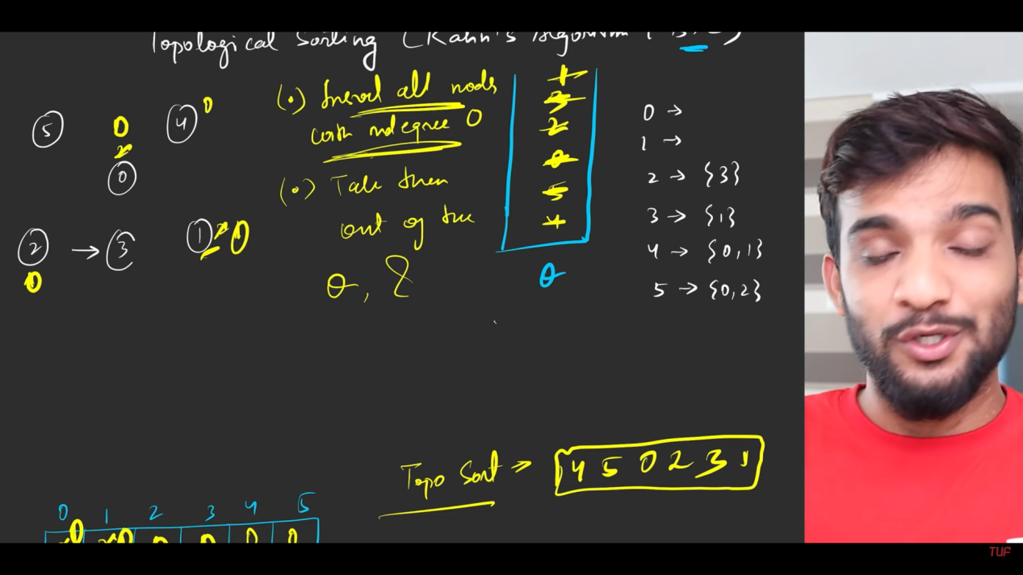
3. 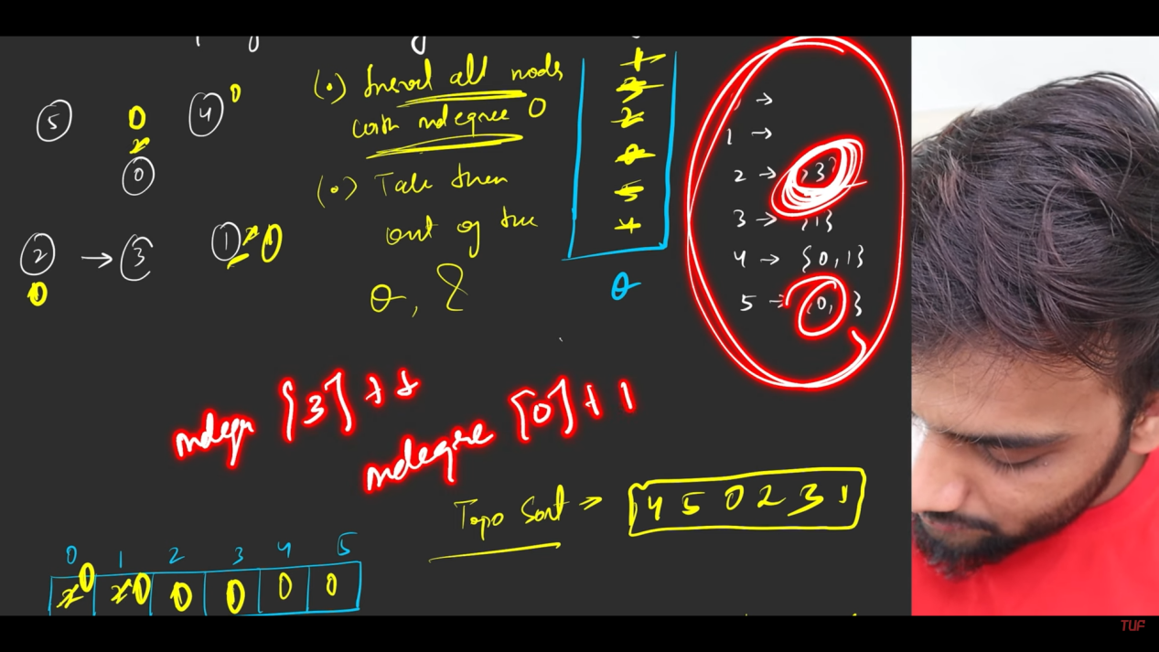
4. 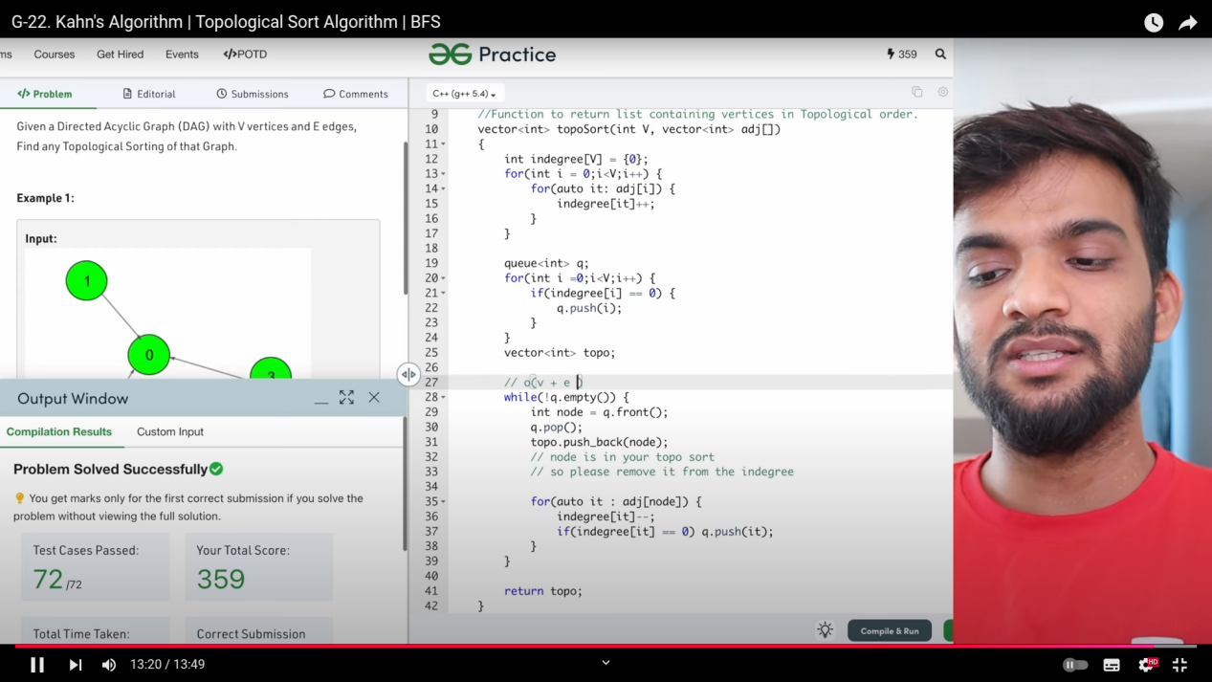

**Detect Cycle in Directed Grah using BFS.**

1. In DFS we used:
   1. path_travelled: While we were travelling returning from the DFS, we used to reset this.
   2. node_visited: When the node is visited, then there is no need to use the visited vertex again .
   3. In DFS, we used backtracking. That cannot be used here.
   4. So use Kahns algorthm is used.
   5. By using the Kahns algorithm, I f I’m able to make produce the topo sort of n different elements then There is no cycle.
   6. If I’m unable to make the topo sort of n different nodes, then there exists cycle.
   7. 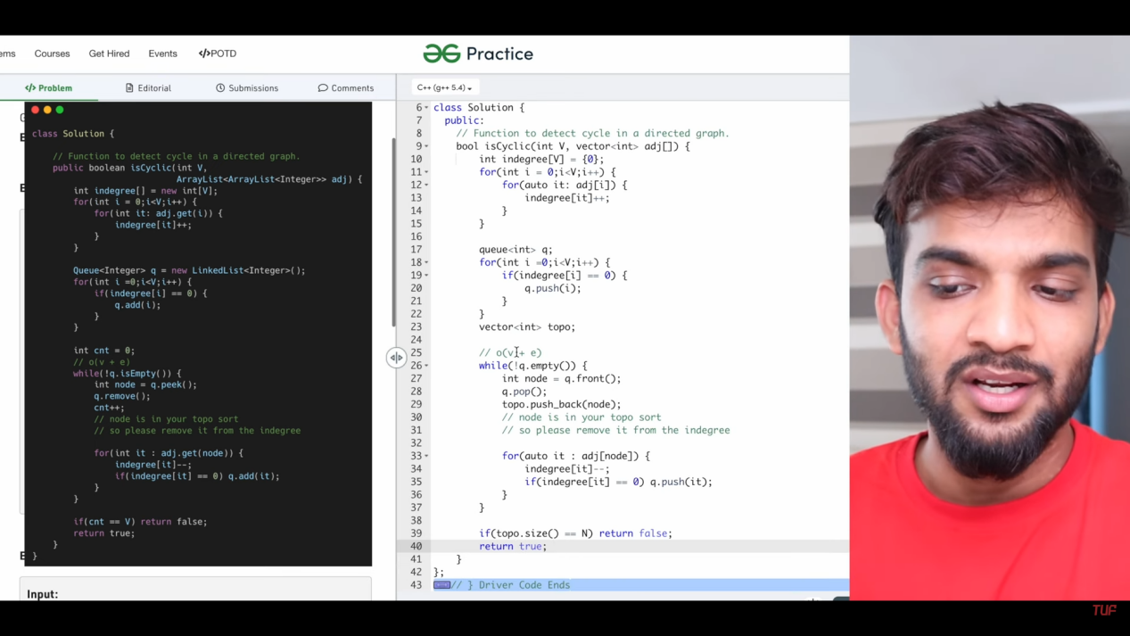
   8. 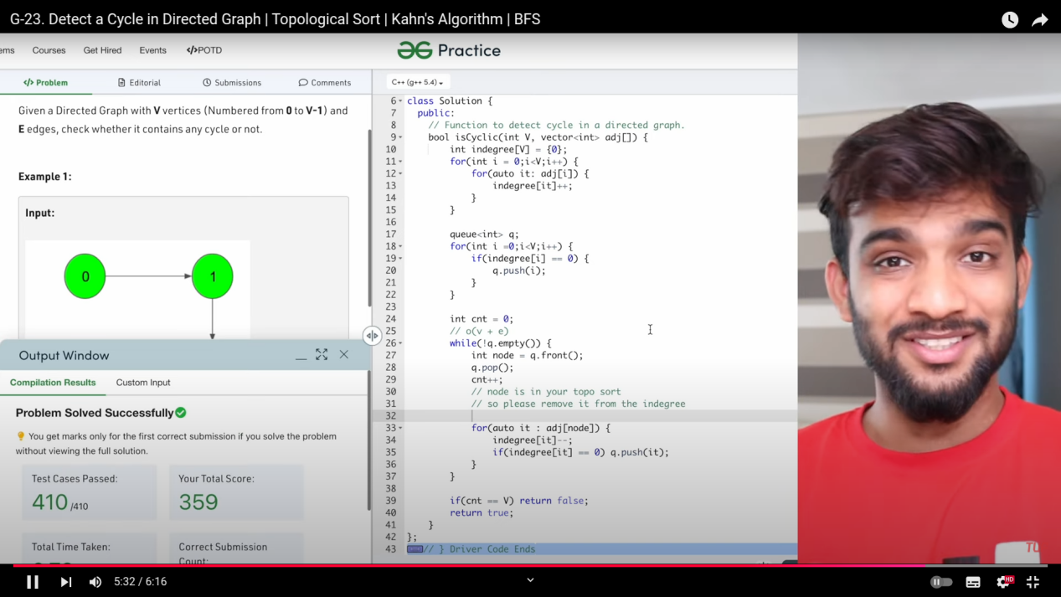
   9. 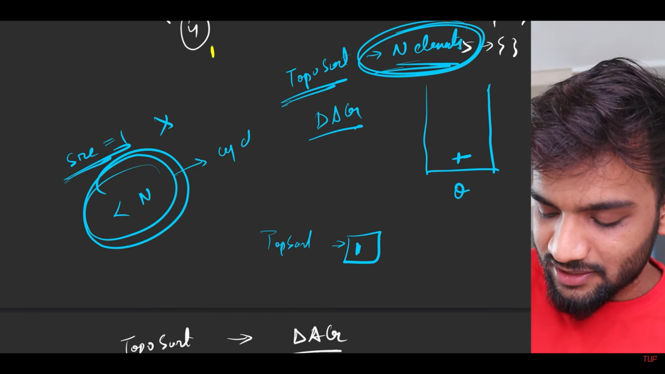

**Course Schedule - I and II**

1. 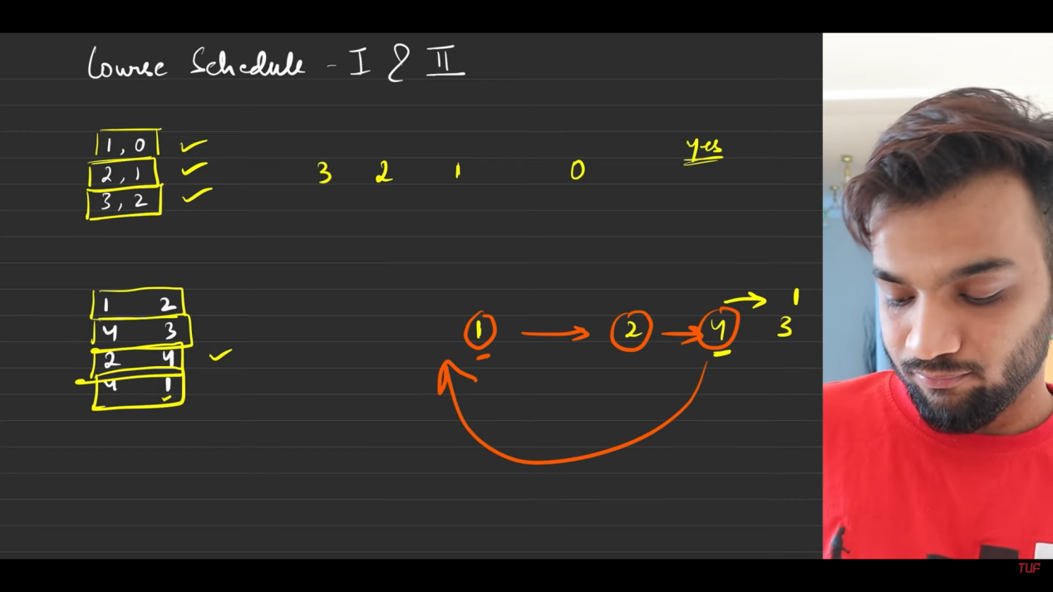
2. Before performing the task 0, task 1 has to be performed. Before performing task2 , taks 1 has to be performd, before performing task 3, task 2 has to be completed. That is what is thre in the first entry. But there is no dependency then we can easily makie it.
3. In the seond entry, There is dependency which will cause from scheduling .
4. SO what is the solution, Topo sort, after constructing the adjacency list.
5. 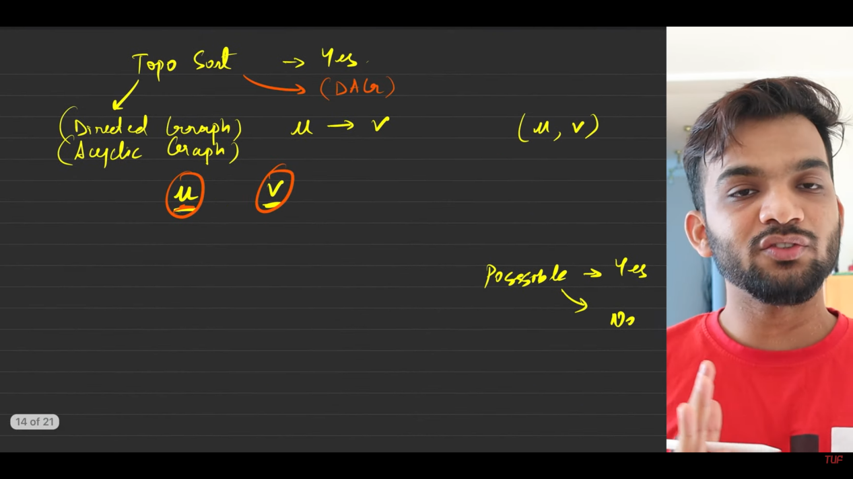
6. 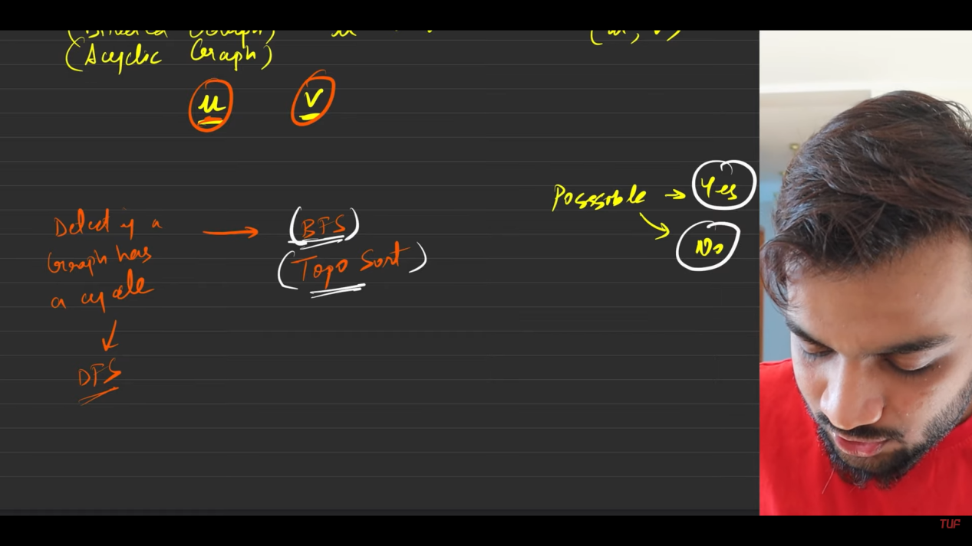
7. 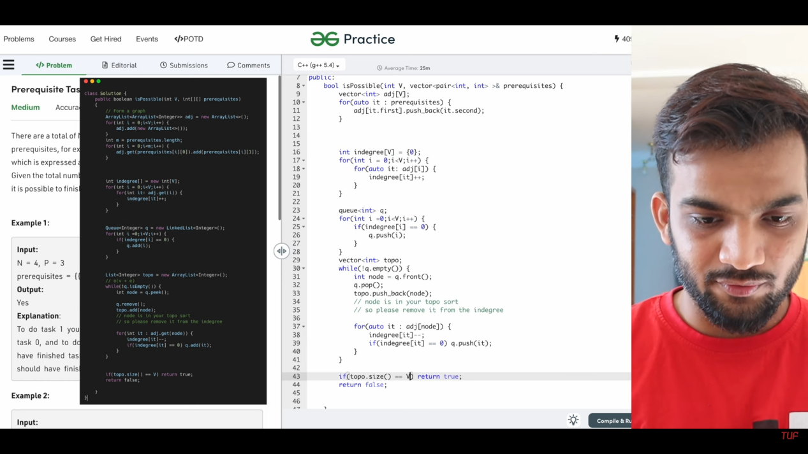
8. **Course Schedule 2**
   1. 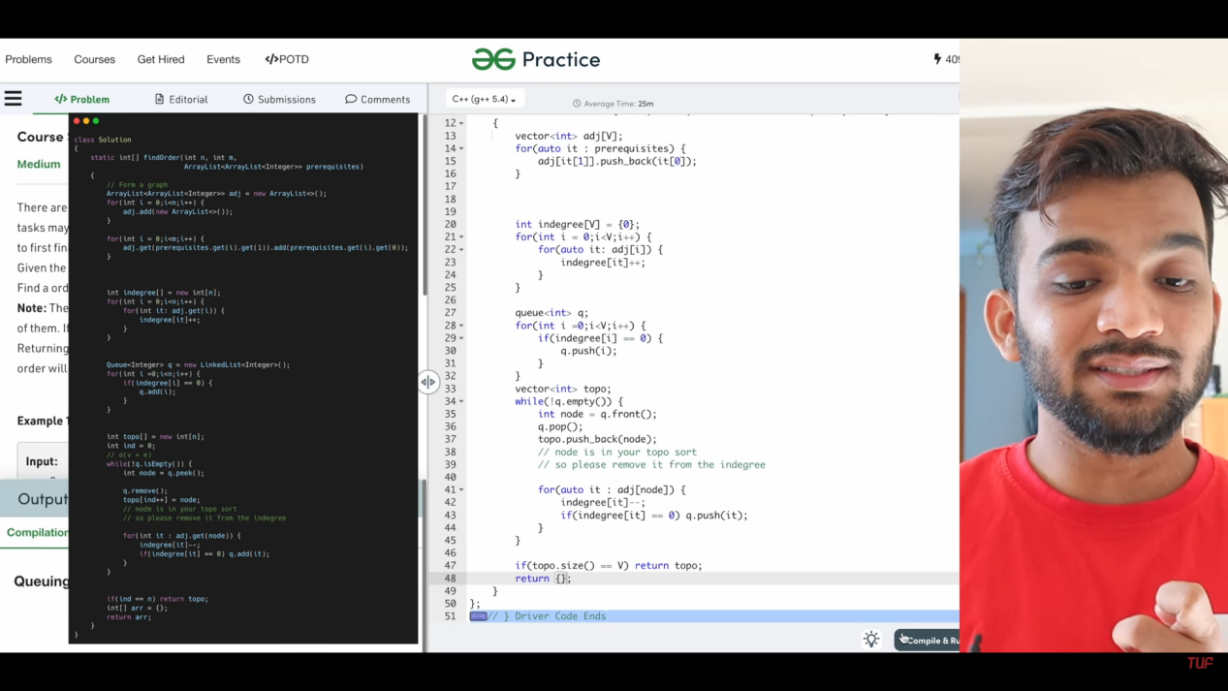
   2. slight modification from the above, in returning and as well as in the storing the values to topo array .
   3. **Important**: Something before something is nothing but topo sort.

**Find Eventual Safe States**

1. 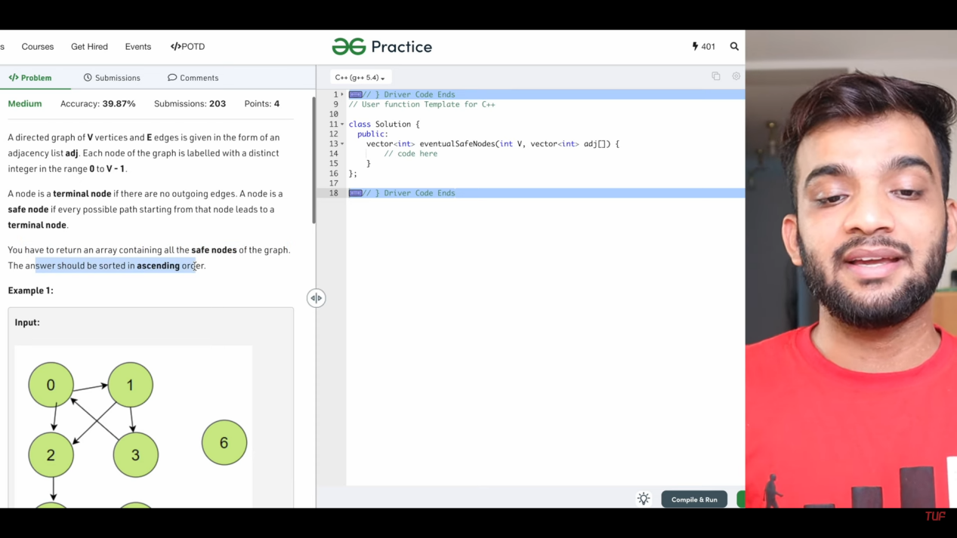
2. Terminal state: There is no outgoing edges.
3. **Safe state**: It is the sequnce of nodes which is in path, from a node till the terminal state, meanwhile it should not be in cycle/ it should not have seperate path to some other node.
4. So it must be the part of a single path.
5. 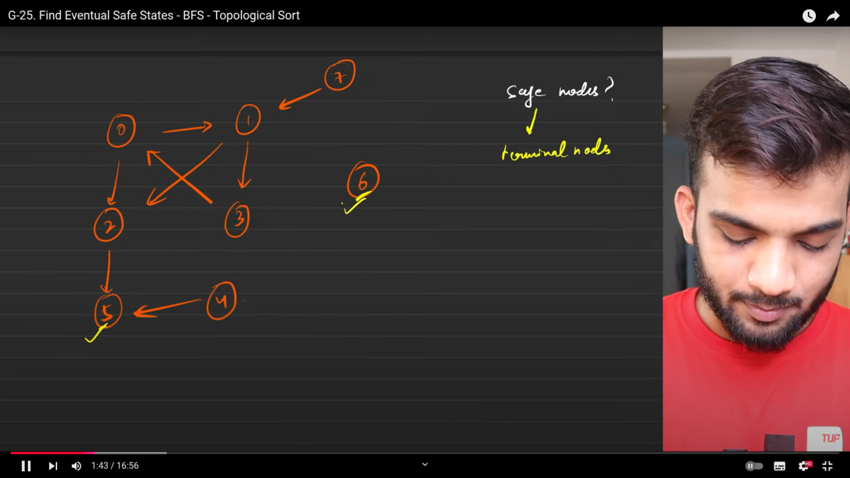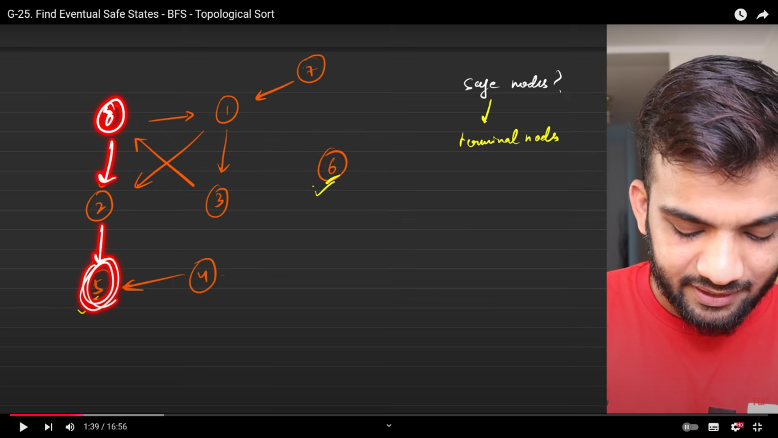
   1. There is a path from 0 to 5, where 5 is being the terminal node. But 0 is also in some path which is not the path from somewhere to the terminal node. So the part from 0 to 5 is not considerd as safe nodes.
6. 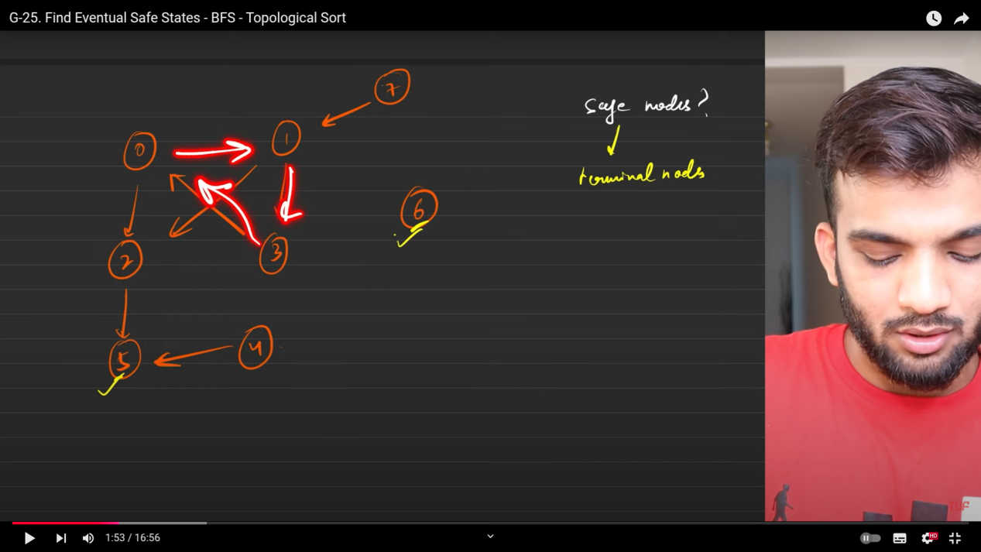
7. 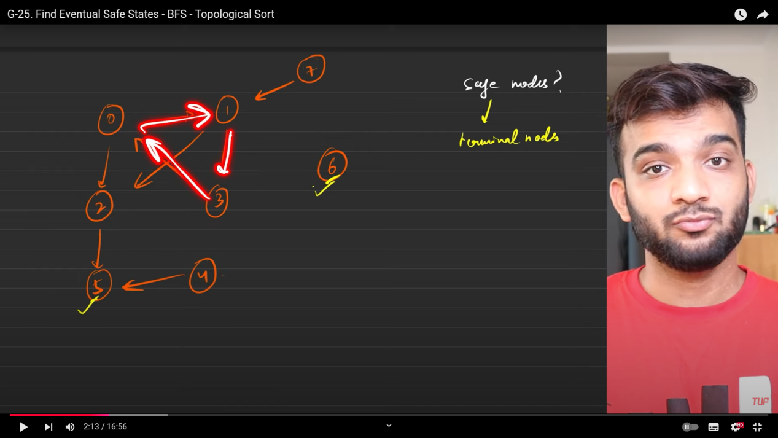
8. You ca see below that 3 being the part of the path from 3 to 5. But is in some other path. which is ending at 3, not ending at the terminal state. This should not be considered for the safe node.
9. 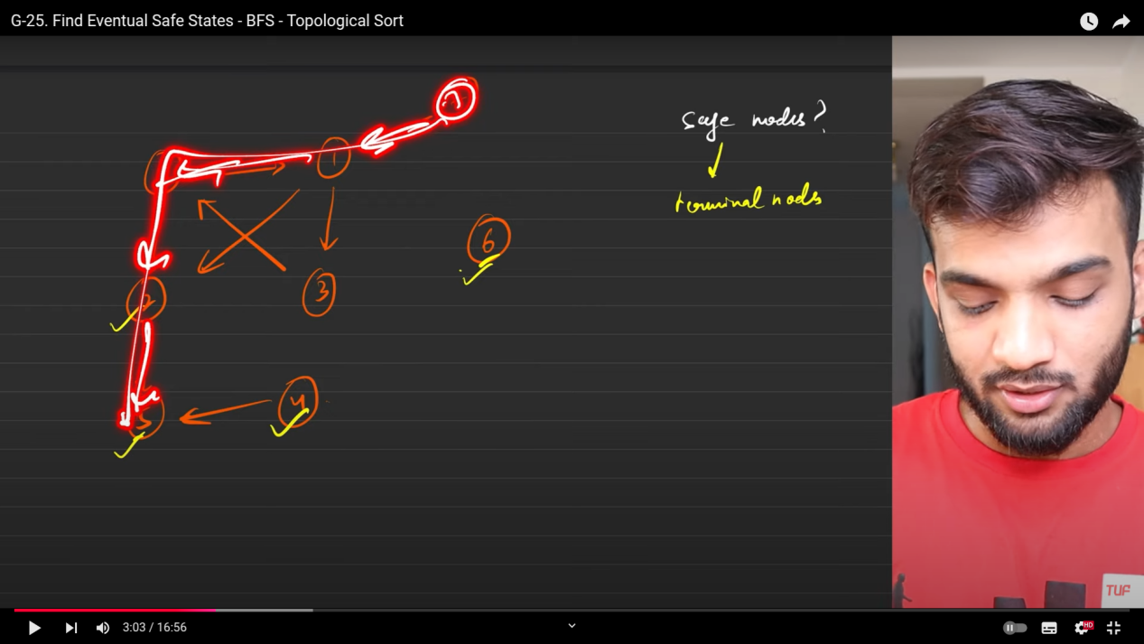
10. There is a path from 7 to 5, but have a look at the next.
11. 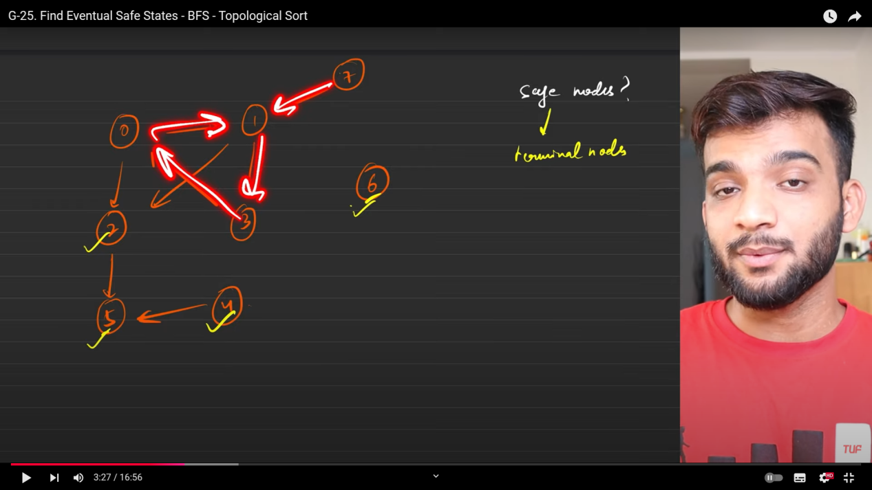
12. The path is also a part of some other path. which is not endng at terminal node.
13. 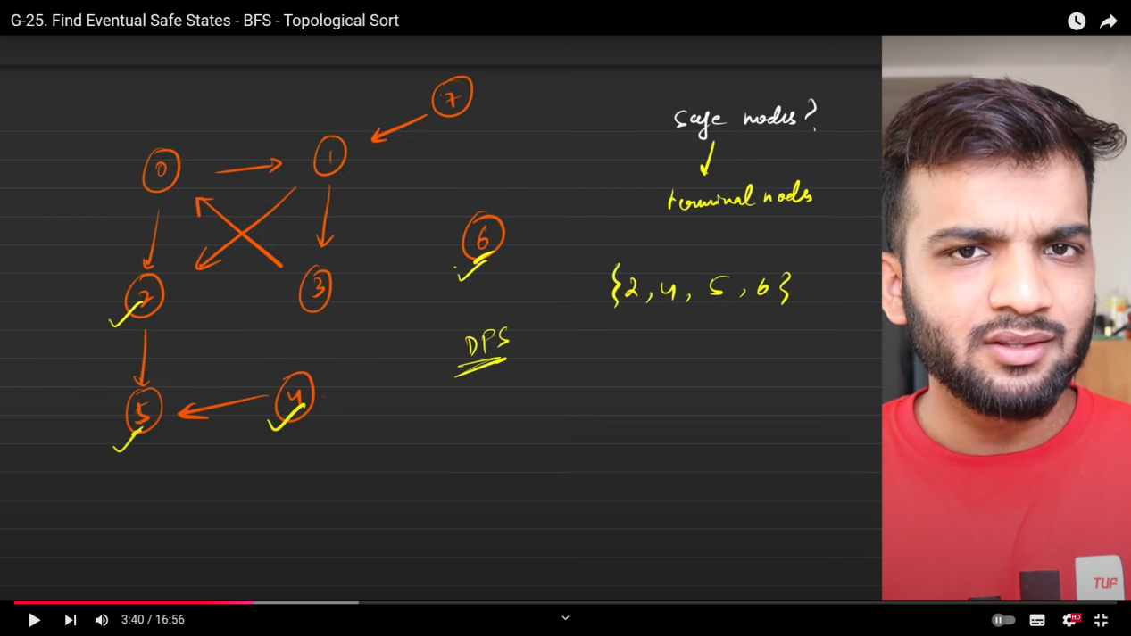
14. **safe nodes**: The node which has path from itself to the terminal node and path do not have anything in between as its path. Then those nodes are called as safe nodes.
15. This is a place you must remember you have to apply topo sort. But the topo sort works only with the inorder, no outorder.
    1. So you have to reverse all the edges, initally .
    2. The terminal nodes are the one which are having the indegree 0, so consider those nodes into queue and then start applying for the BFS traversals.
    3. 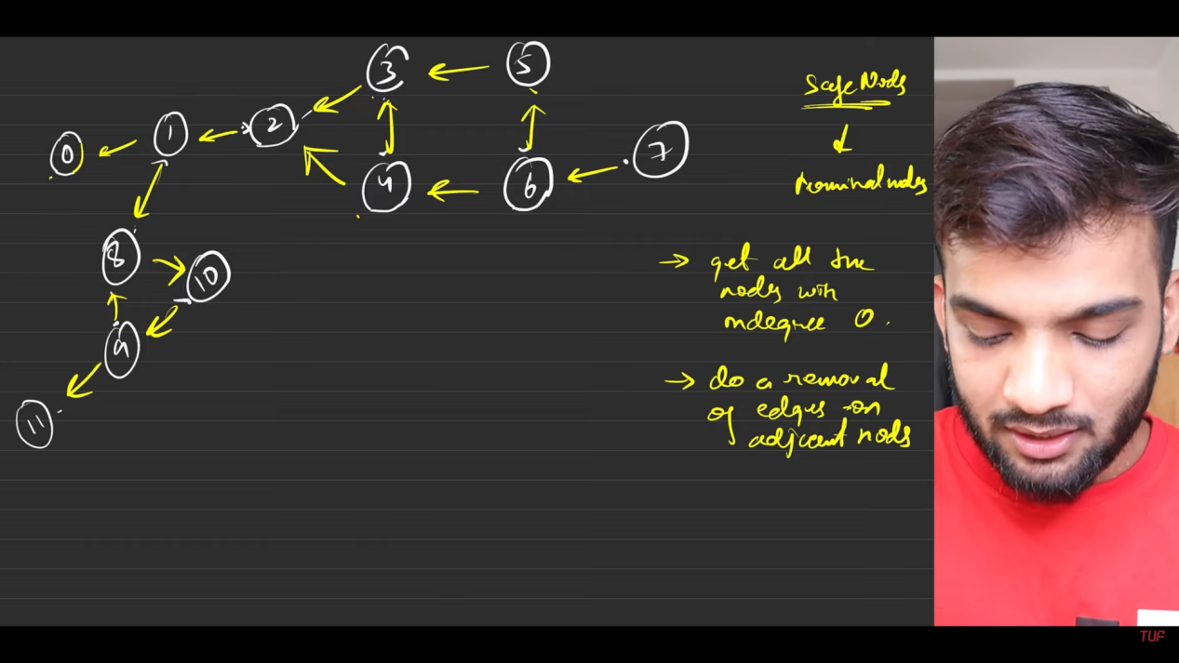
    4. So the nodes which are nearby or reachable from the node, will be removed edges from the graph and reduce the indegree by 1. for whom the indegree ws flowing .
    5. 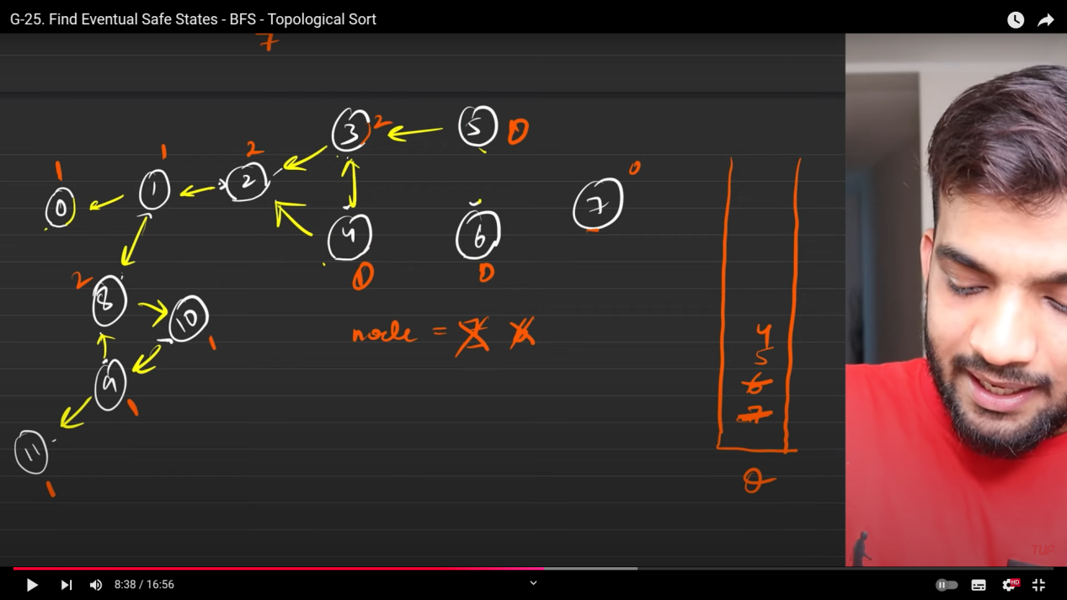
    6. So who are al; getting zero, those nodes will be considered into the queue. then again led for further processing.
    7. When the queu becomes empty we will have the safe seqence , sort and give the result.
    8. 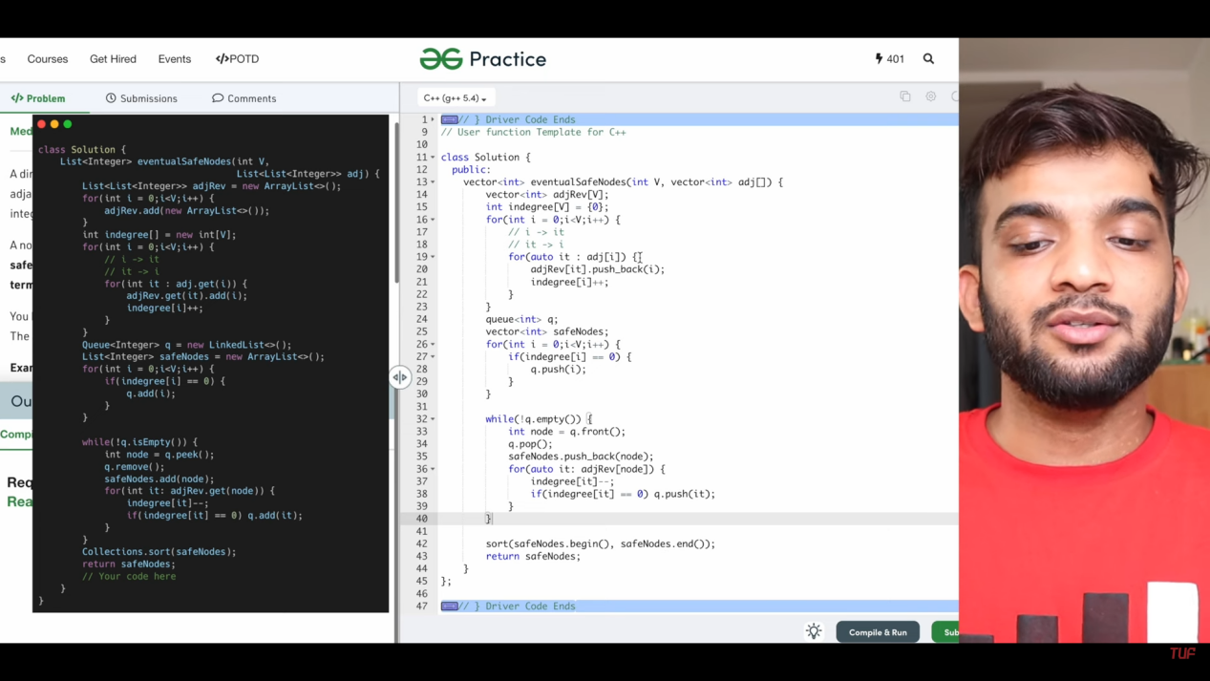

**Alien dictionary**

* 1. 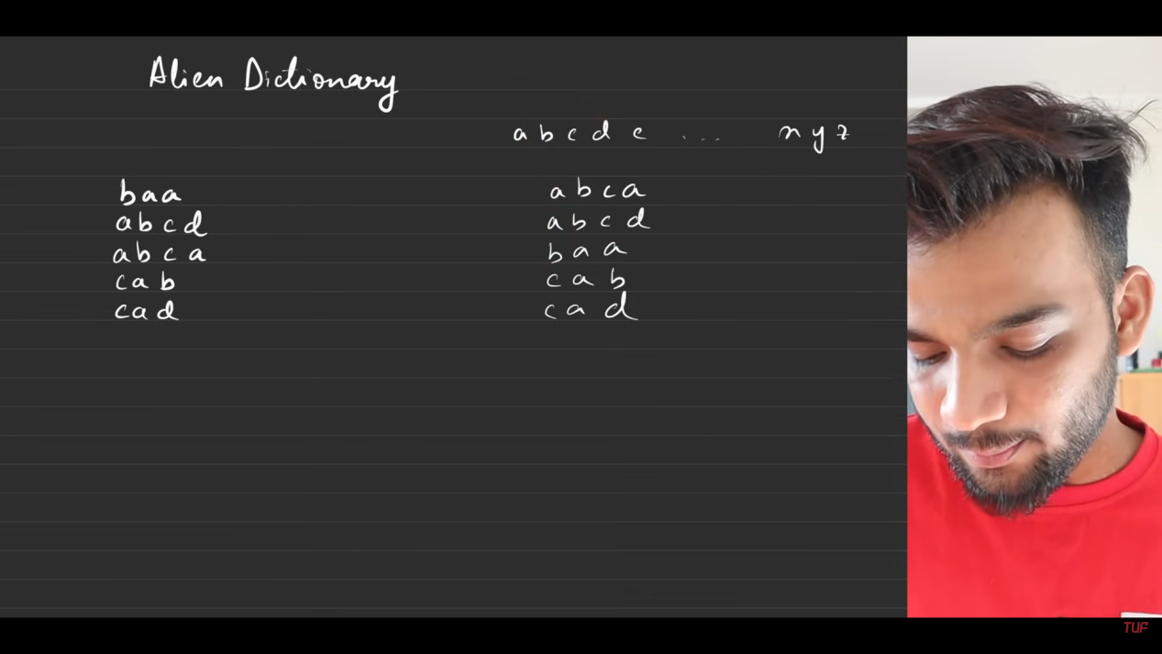
  2. Human dictionary - right. Alien dictionary - left.
  3. 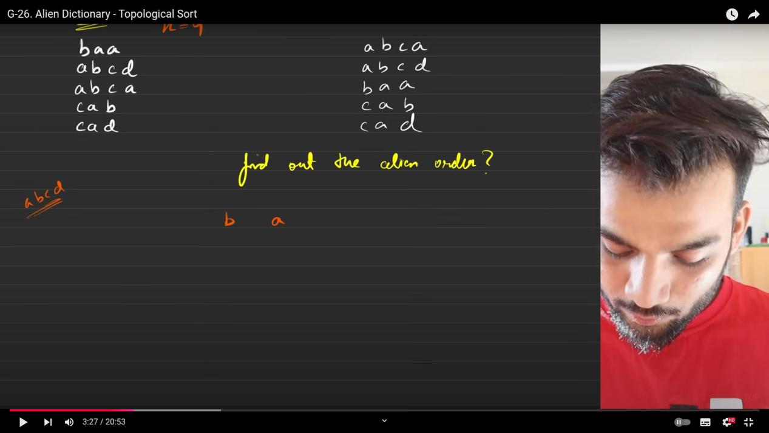
  4. Comapring the first 2 words.
  5. 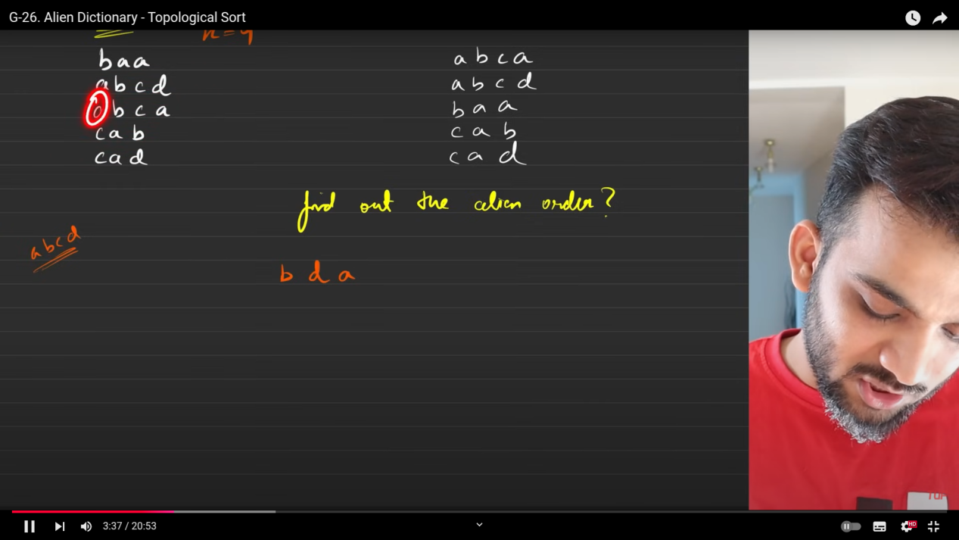
  6. 2 and 3rd word.
  7. 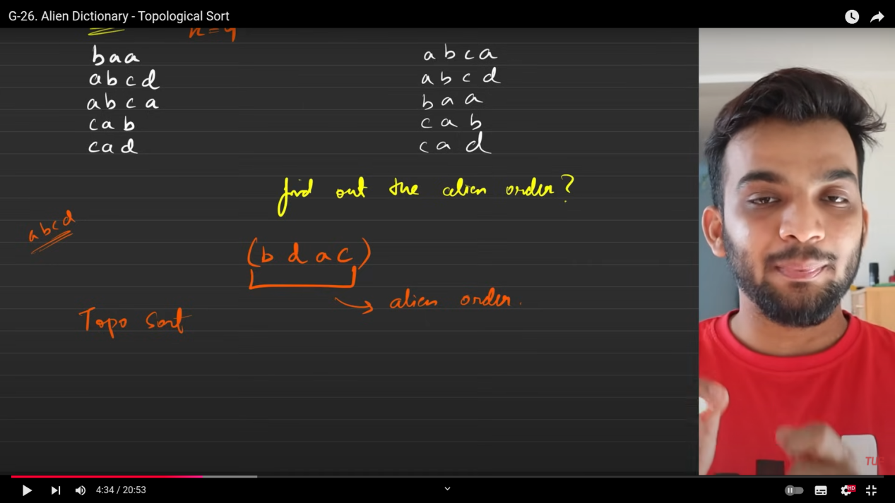
  8. ABove is speaking about something before something. Hence topological sort.
  9. Create the DAG(only then topological sorting works).
  10. 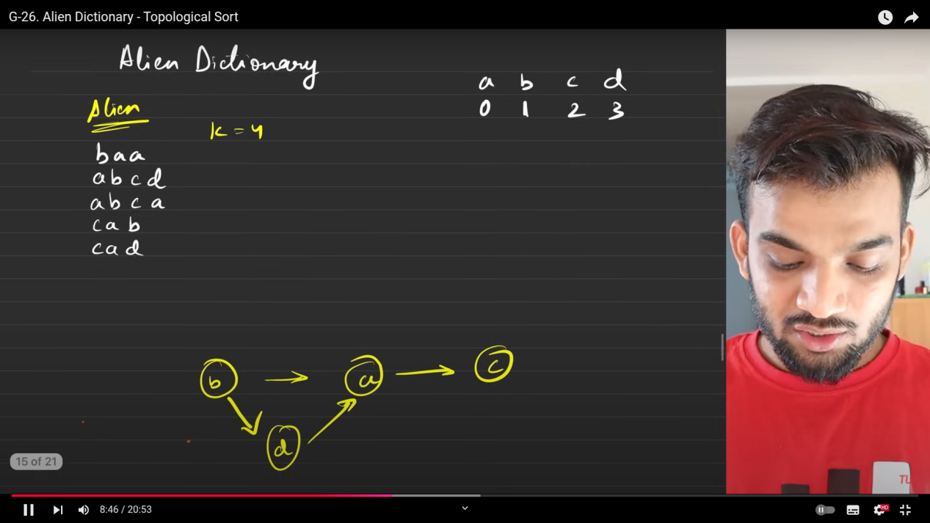
  11. In the above case we have created the DAG with the 4 nodes and as well as the k=4 is given so there is no problem with it.
  12. When k is goven more than the number f nodes, thenn we have to consder the next elements in the human dictionary and that can be applied in any order with the DG.
  13. Then perform the topo sort technique. 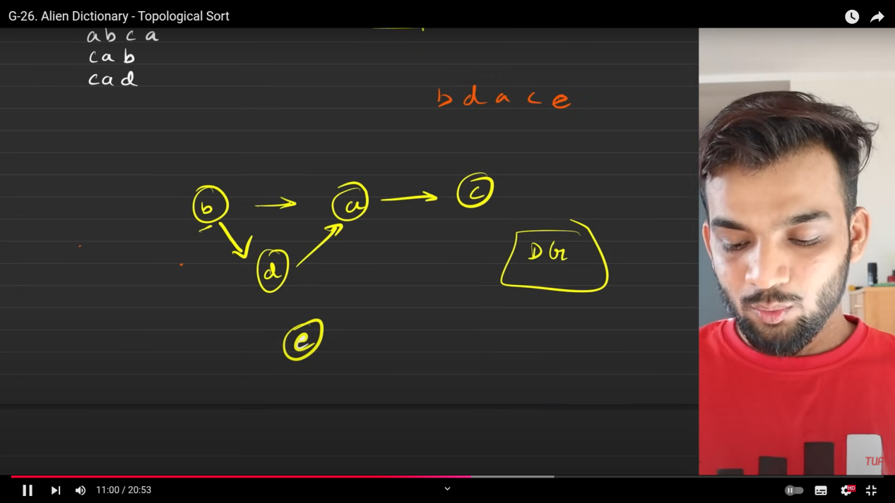

1. Pre - processing :  
   Analyse the given set of words(differntiate set of factors).  
   Based on that create the DAG
   1. 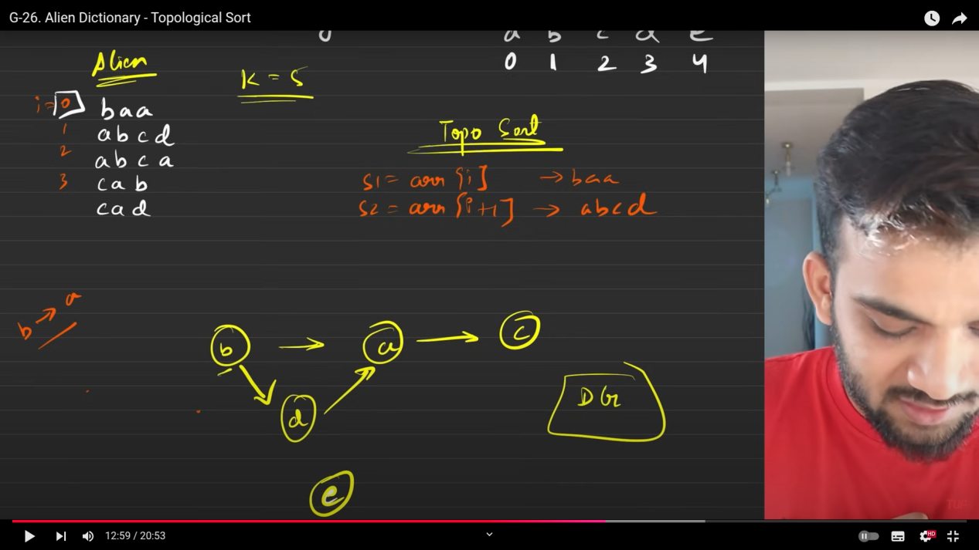
   2. 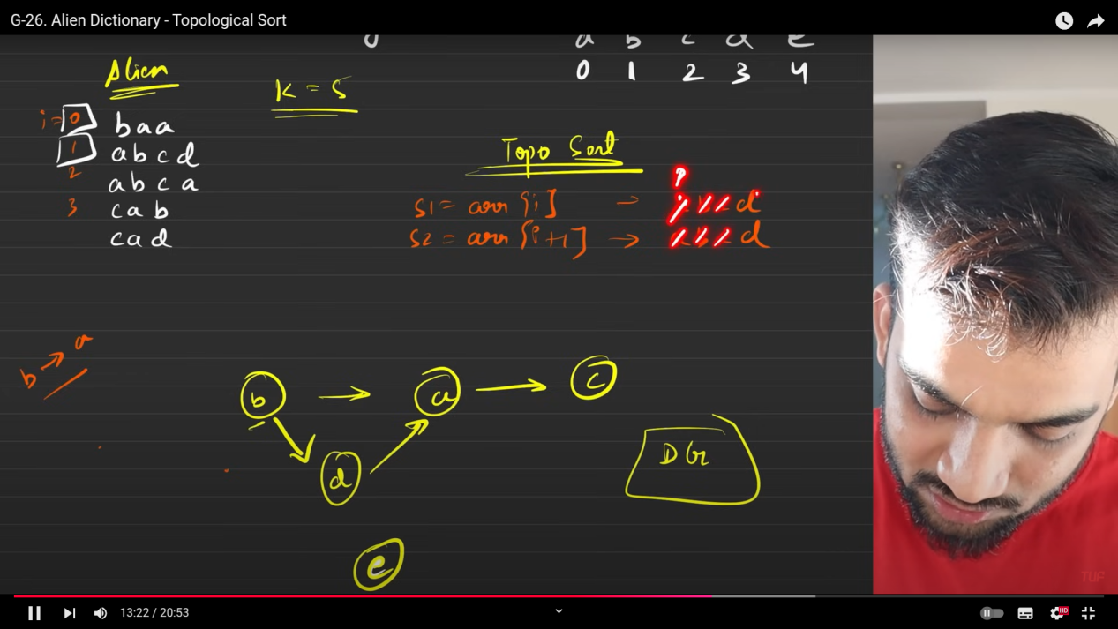
   3. 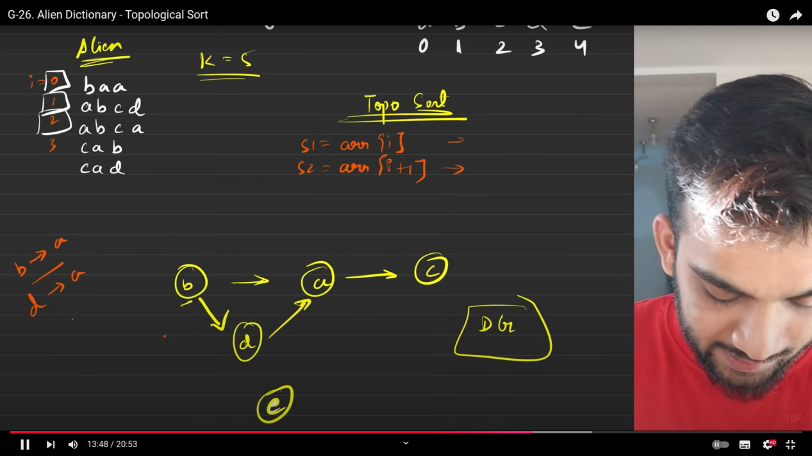
   4. 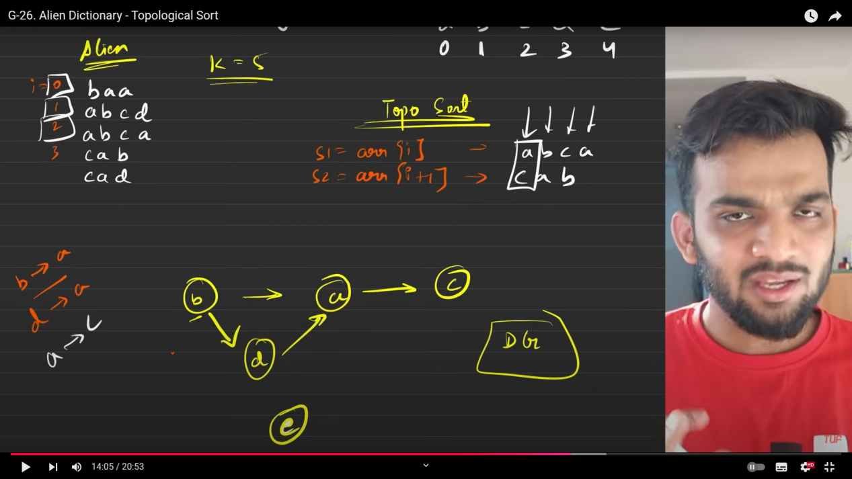
2. Applyt the topo sort
3. 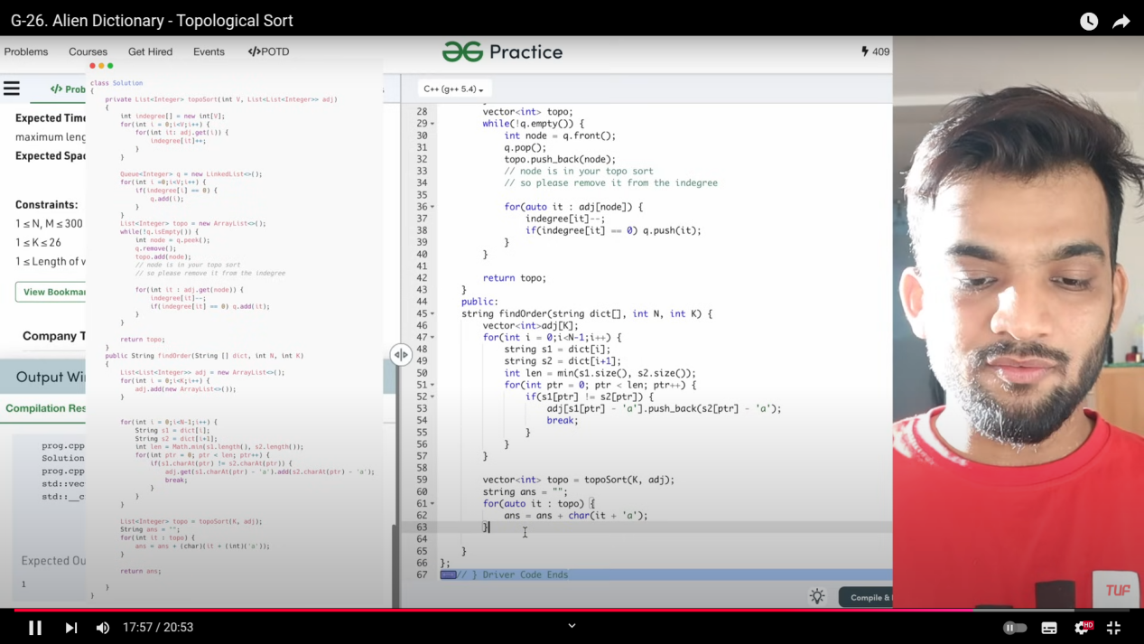
4. 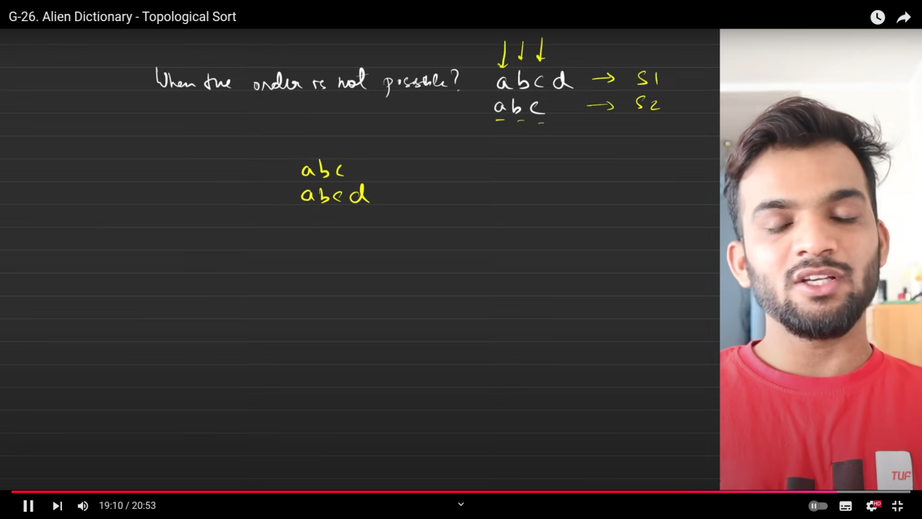
5. If everything is matching and the largest string is before the smallest string the n ordering is not possible. Else the ordering is possible.
6. Cyclic dependency is also not possible.
7. 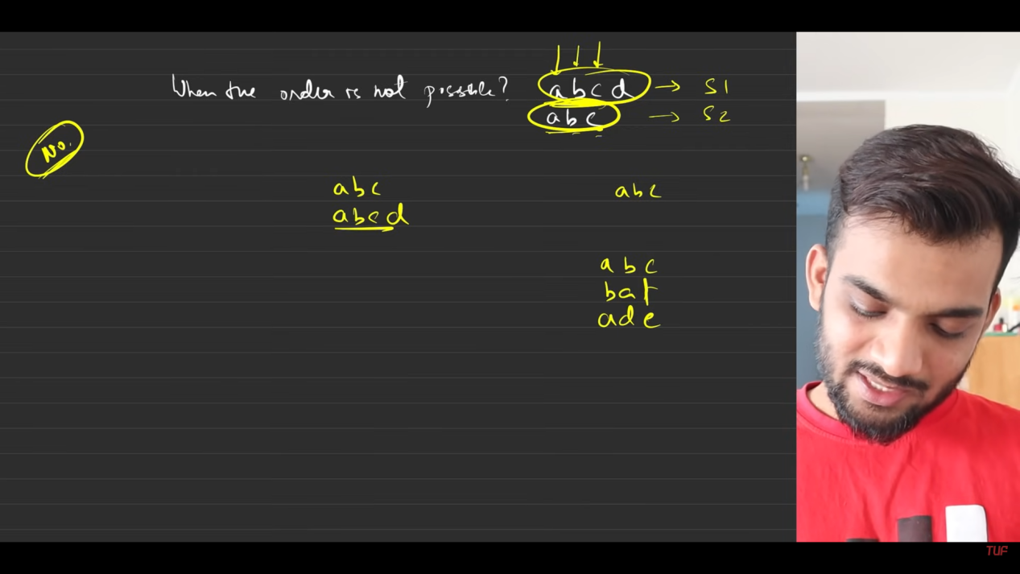
8. 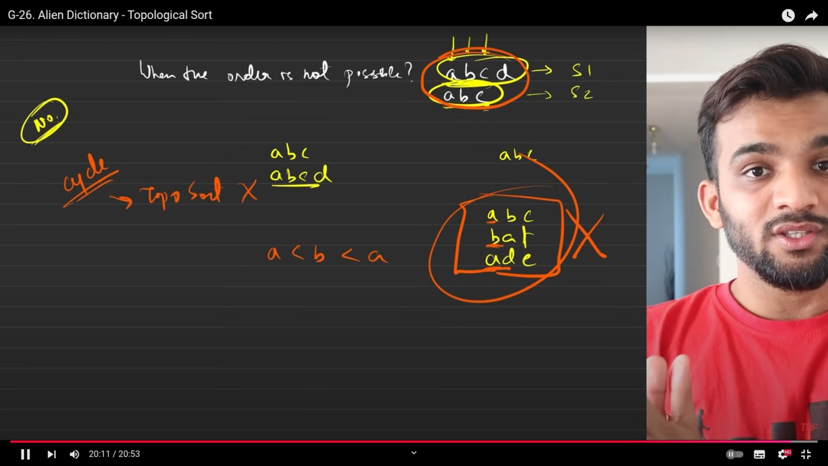

**Word ladder 1.**

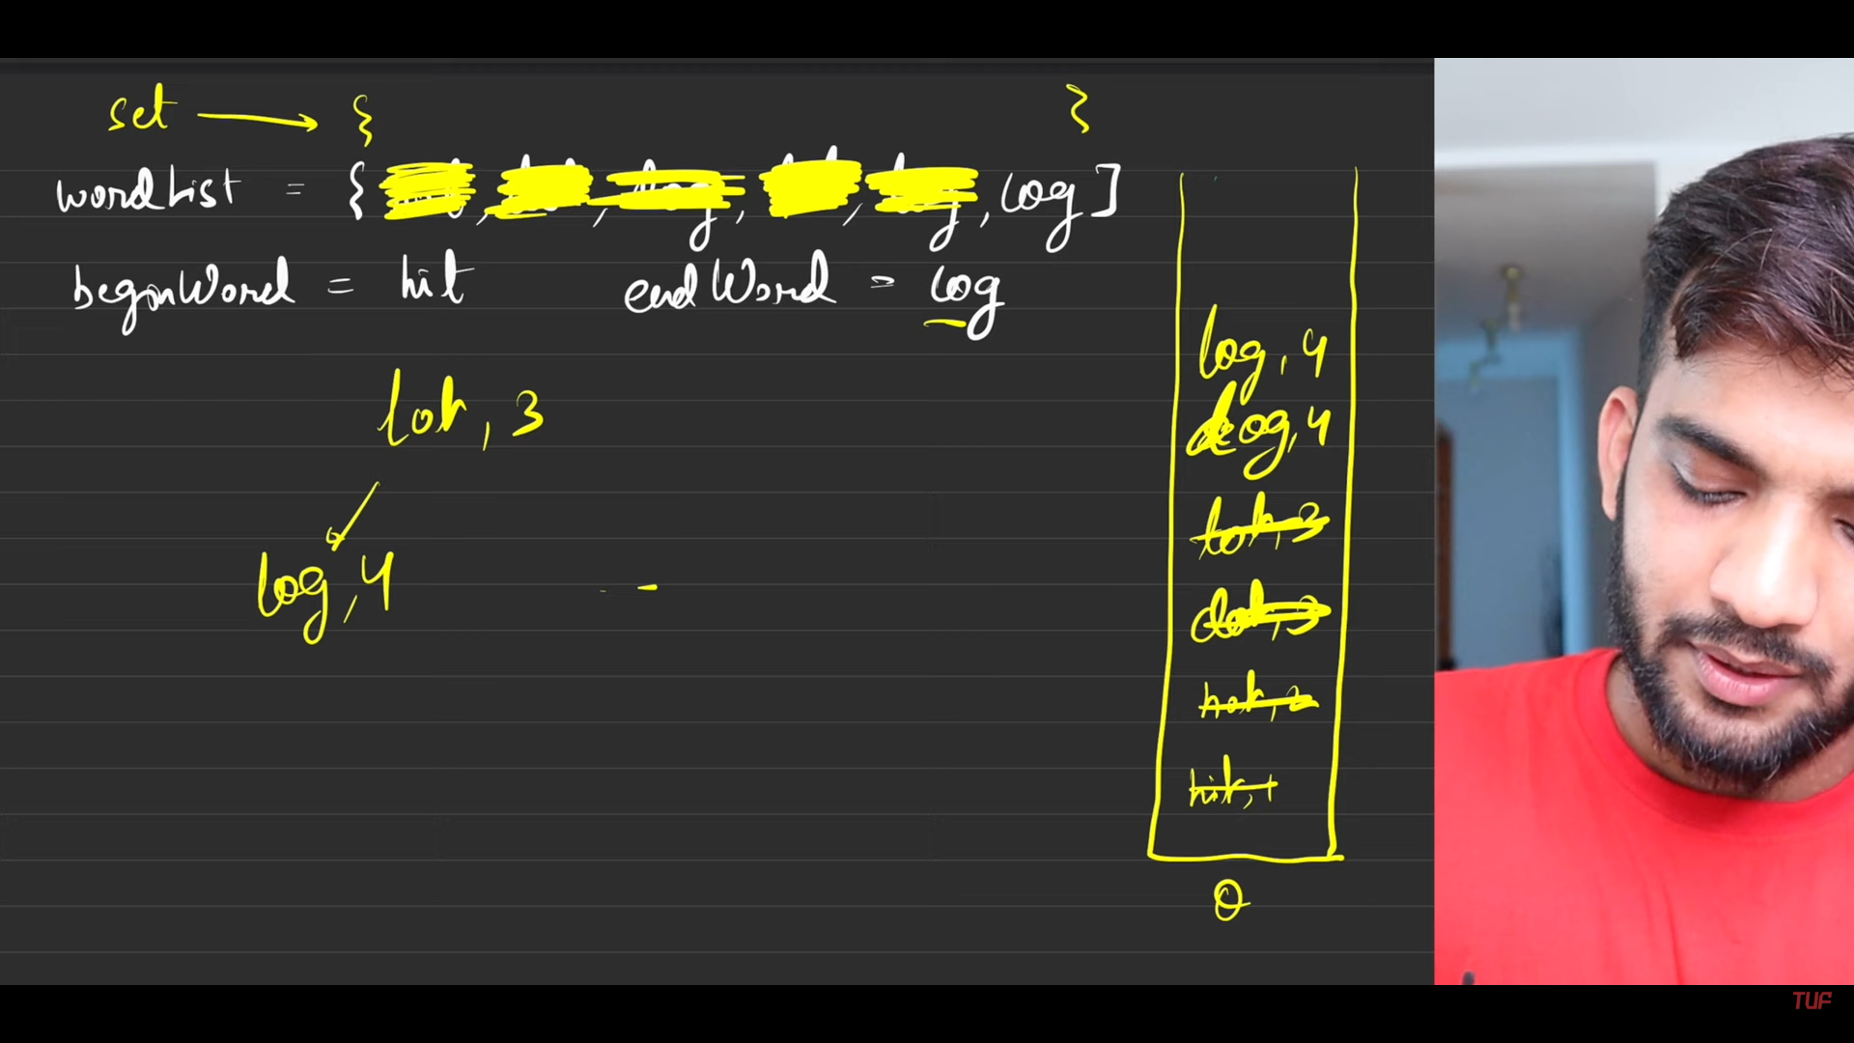

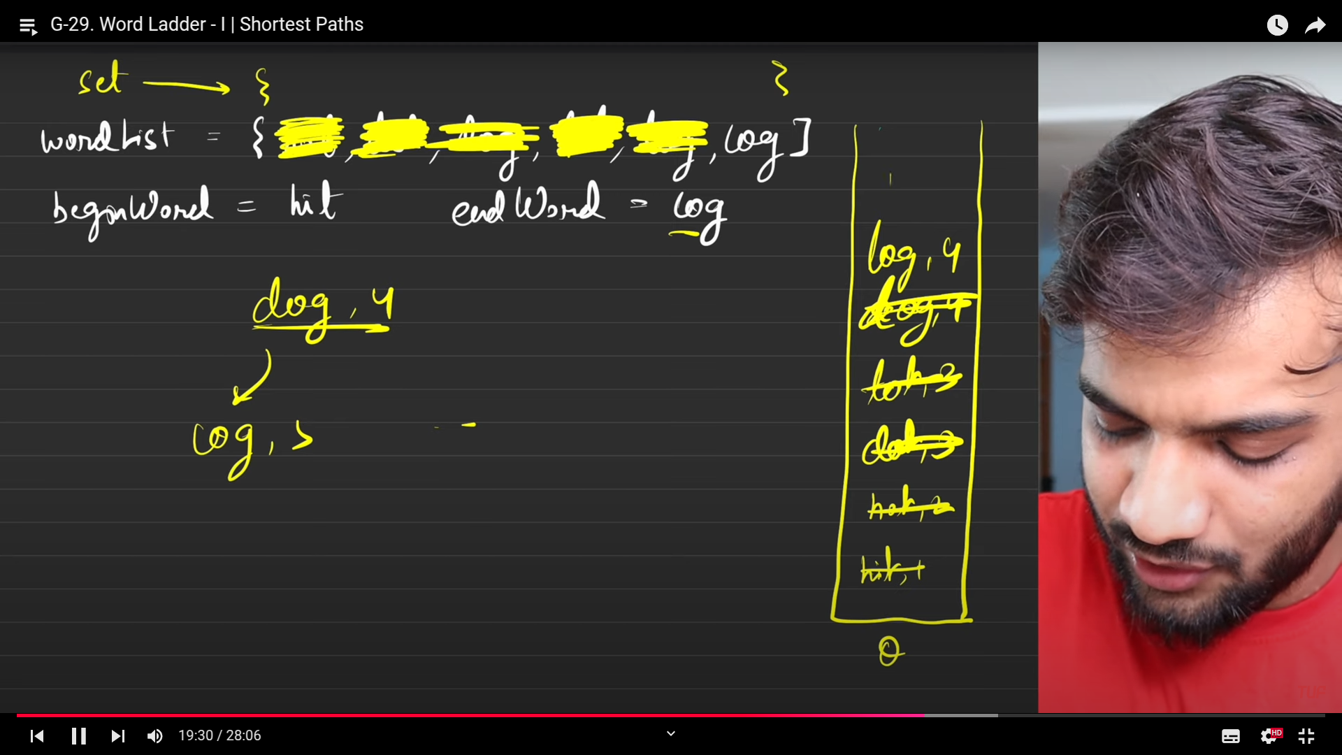

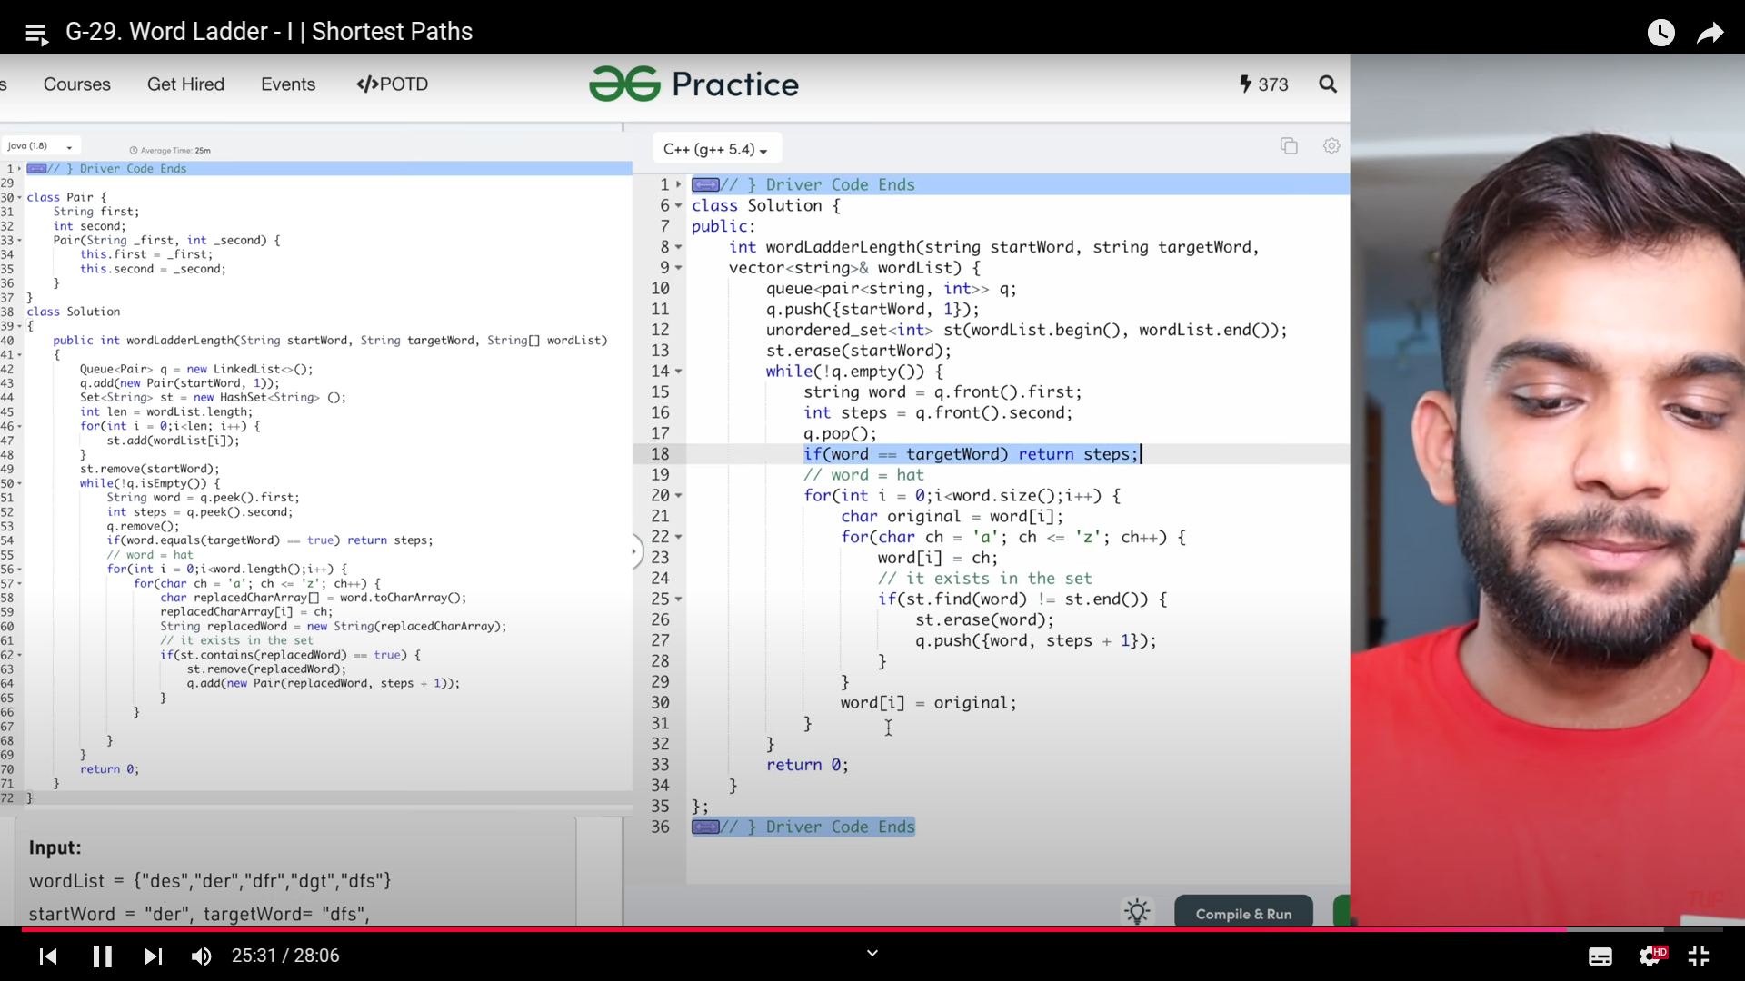

**Word ladder 2:**

1. 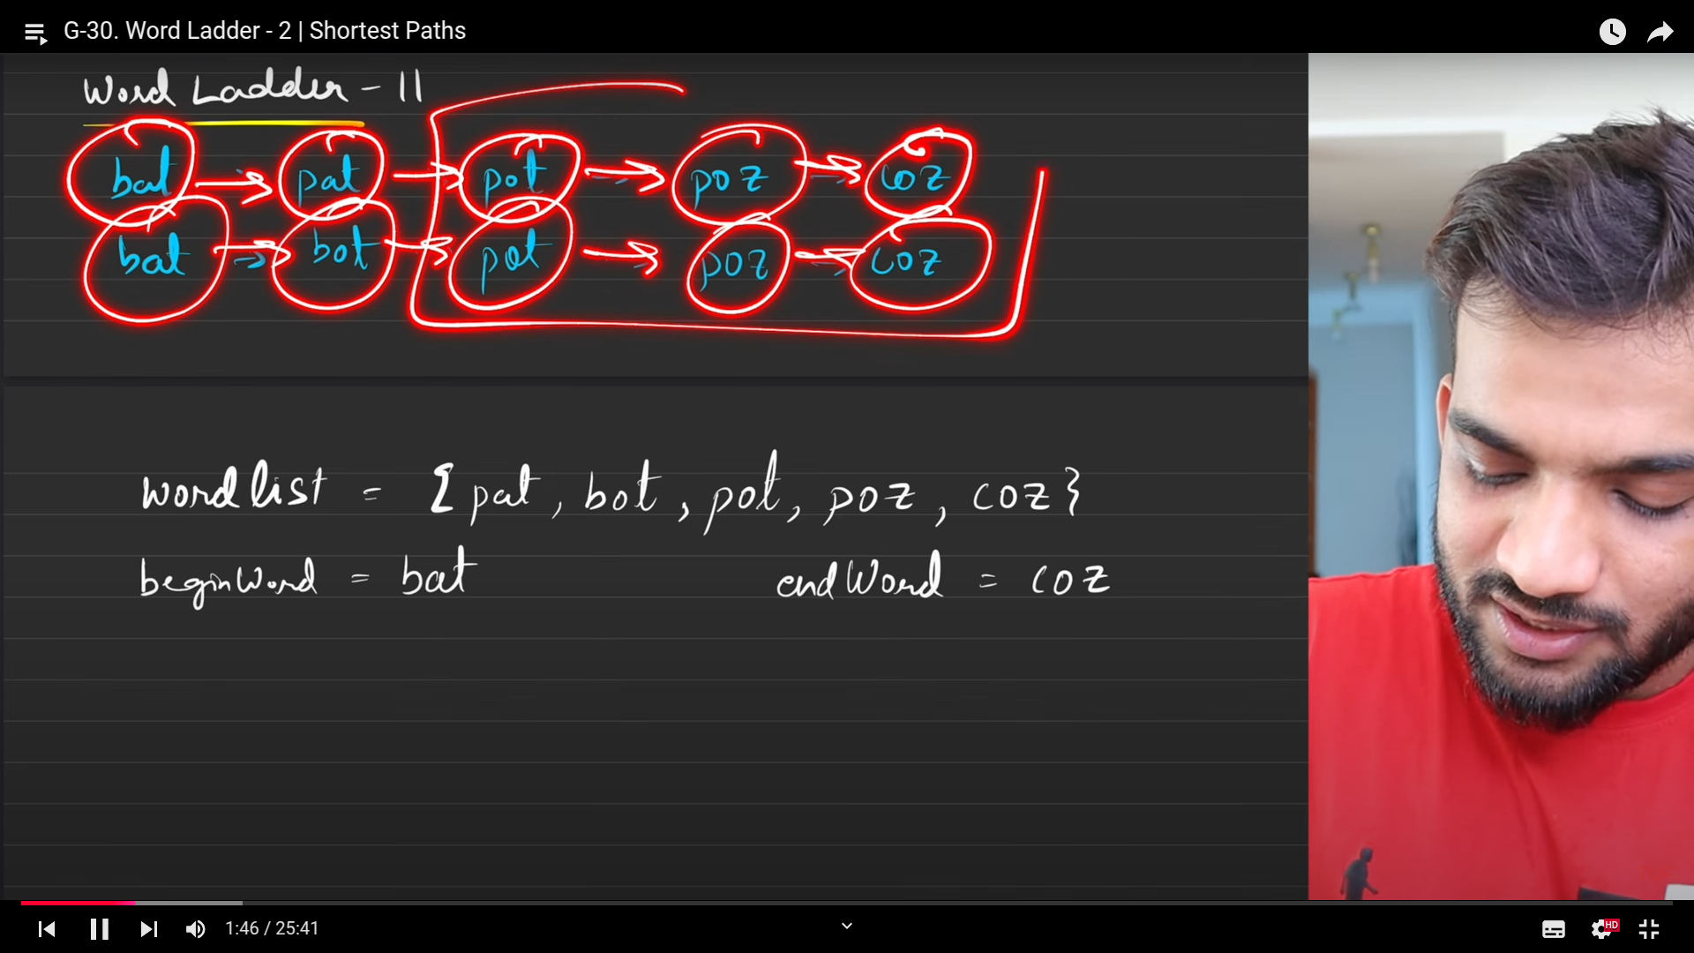
2. 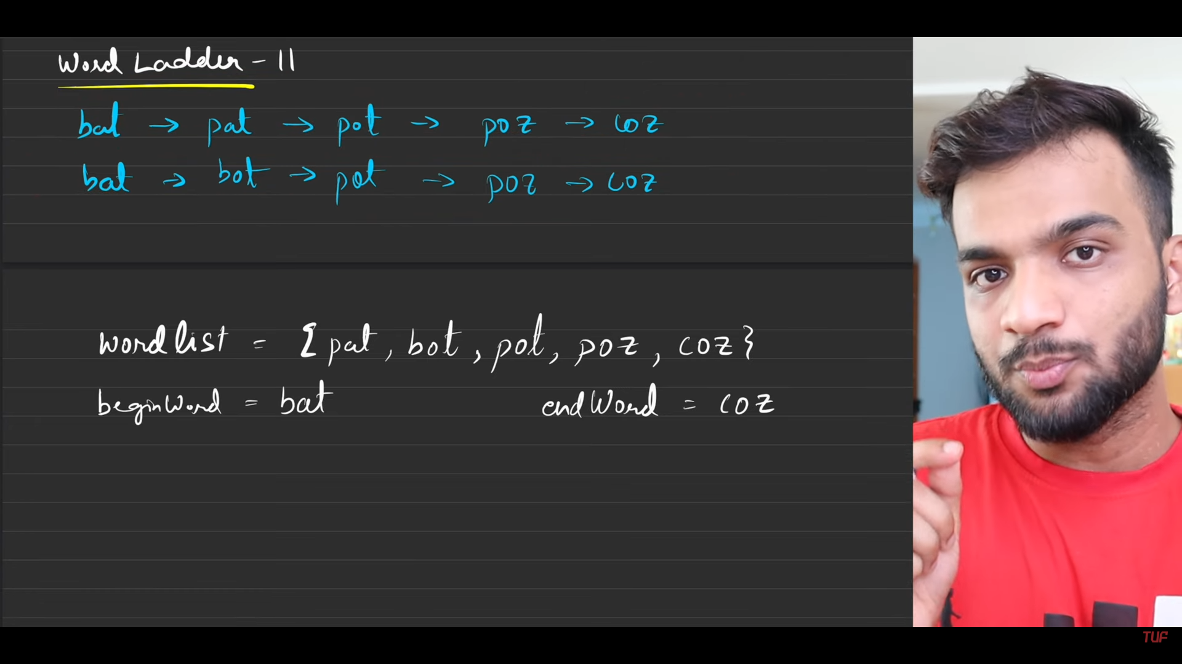
3. 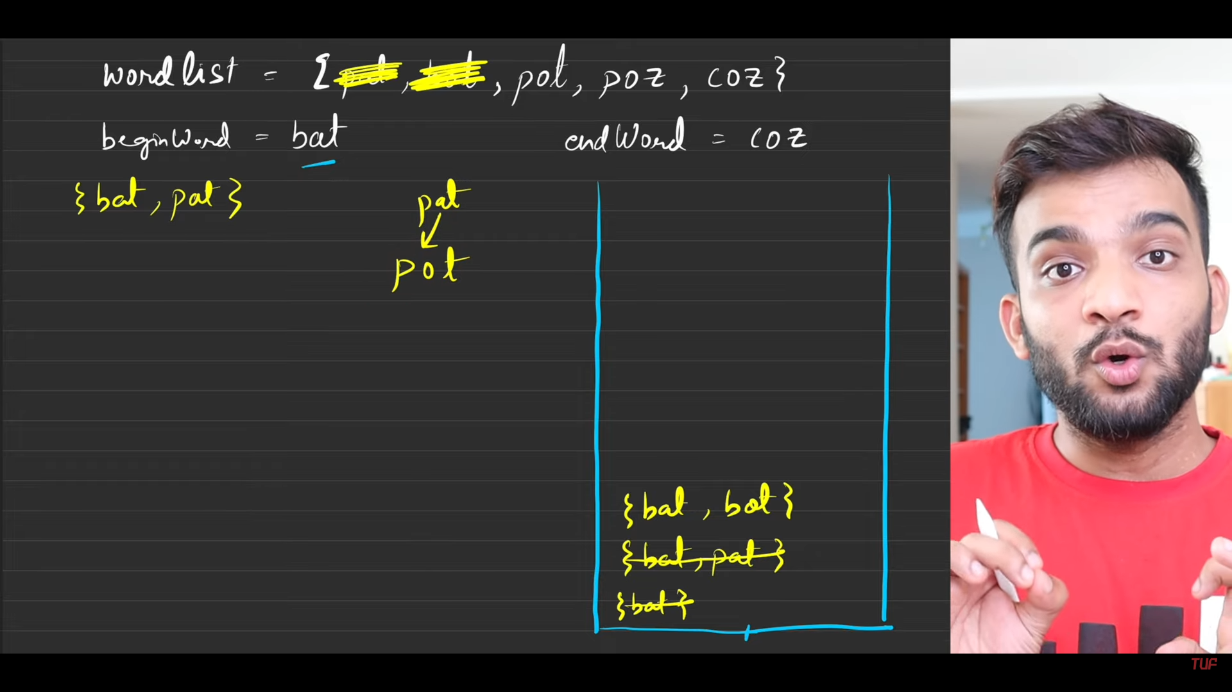
4. 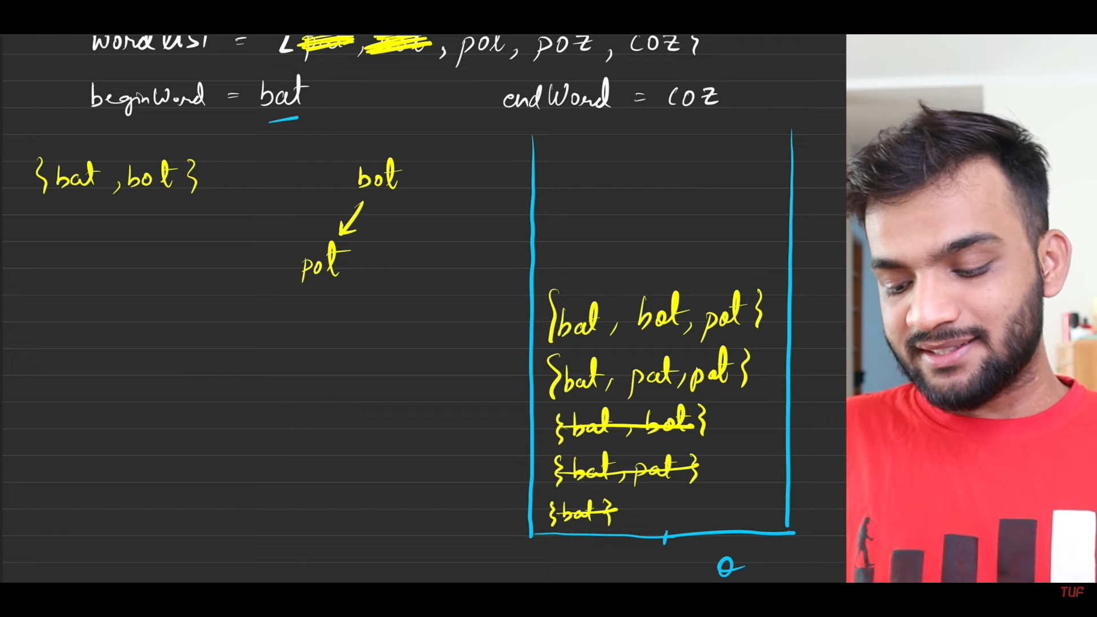
5. Like previous once you found the value in the set, the word will not cleared from the set. It has to wait till this level is completed sonce we are focusing on returning the path from the current node till the target word is reached. And there can be many number of paths from start to the end, but the subset of the path seems to be same everytime.
6. 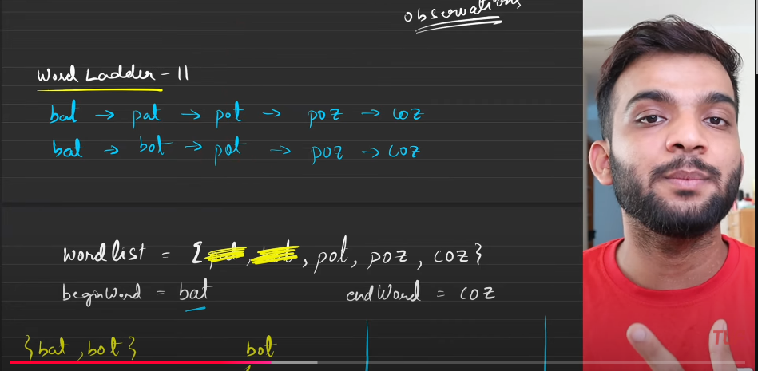
7. 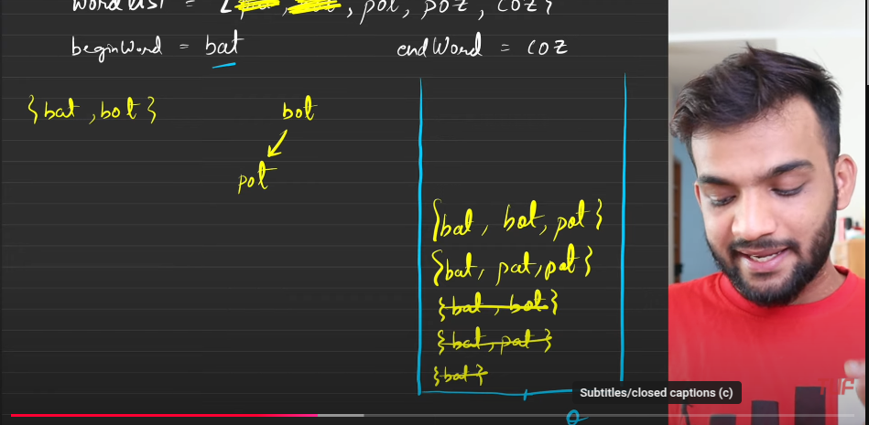
8. All my level 2 has been completed, you can clear the word.
9. 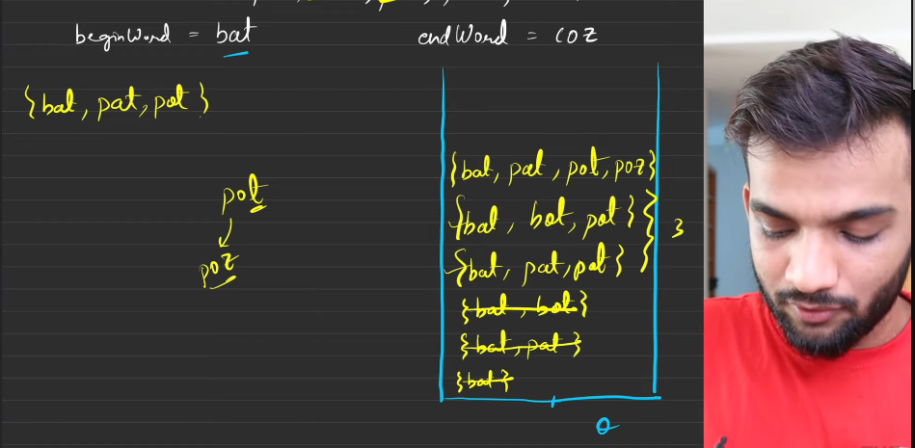
10. 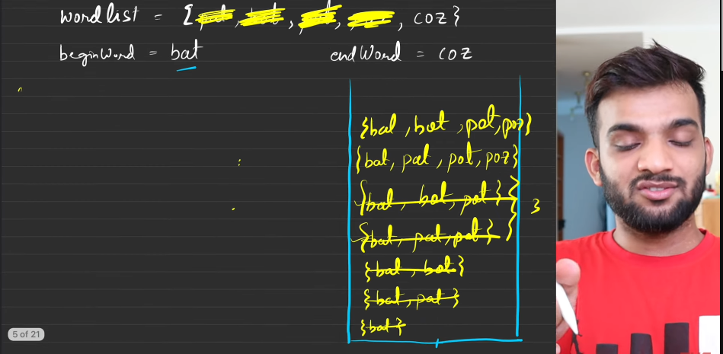
11. 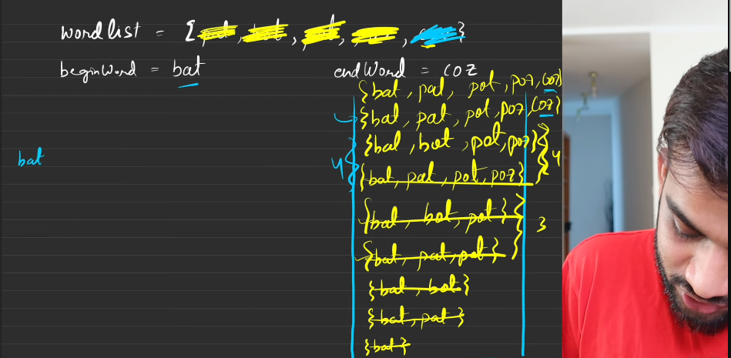
12. 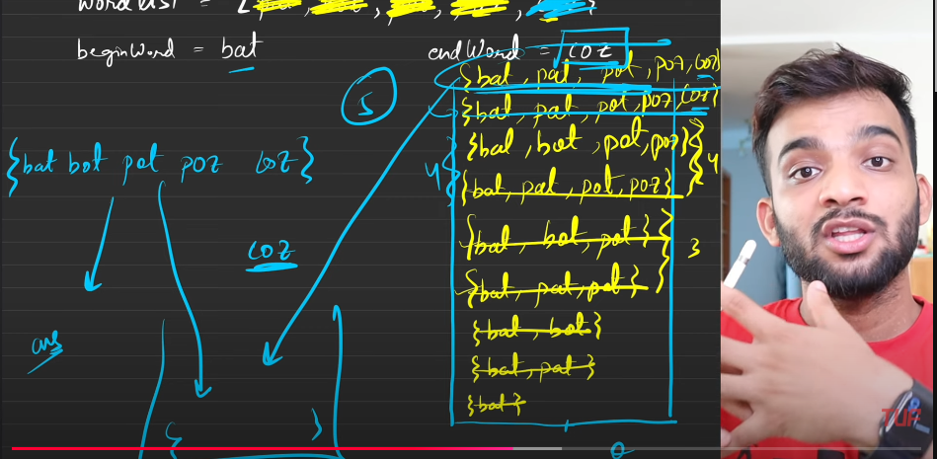
13. 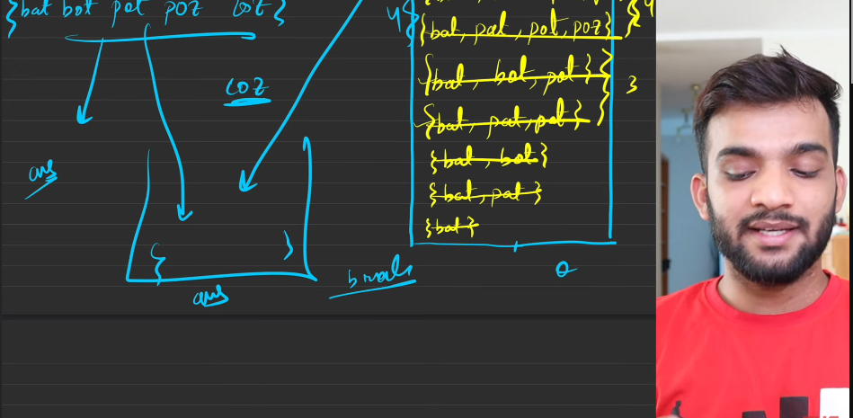
14. 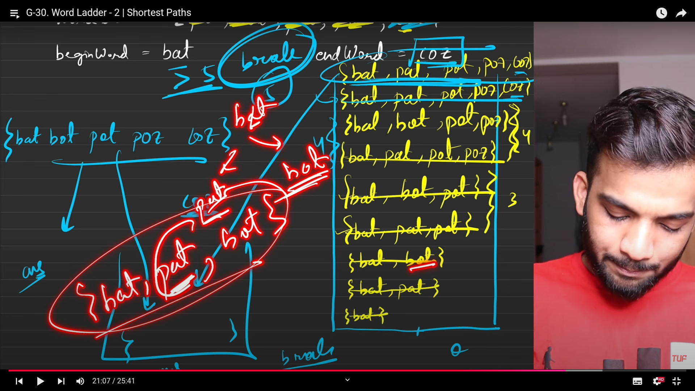
15. Solutions from my side, if it does not fits then you have to code it by yourself.
    1. This is the problem where we will be sending the path from start word till the end word.
    2. There can be multiple paths or word transitions.
    3. algo ;
       1. Trace some some examples as soon as possible, Then come to a conclusion, what are all the data structures needed.
          1. This code is indeed the BFS traversal. So require the queue ds by default, but this is not the only thing. Queue must have the data structure, which can hold the vector of strings.
       2. By default the initial word is pushed into the queue.
       3. Now start applying the BFS, take the word from the queue.
       4. Based on the size of the word, use for loop changing each letter in the string , move from a to z.
       5. After changing each letter, check whether the string is present in set or unordered set. If it available, then add that with the current in queue. => popped from the queue and the one found inside the set.
       6. Insert to the queue, do this till the insertion of the values completed then after coming from the loop, you can remove the value from the set.
       7. This is all about it.
       8. This is interview way of making.
16. This is word of ladder 2. 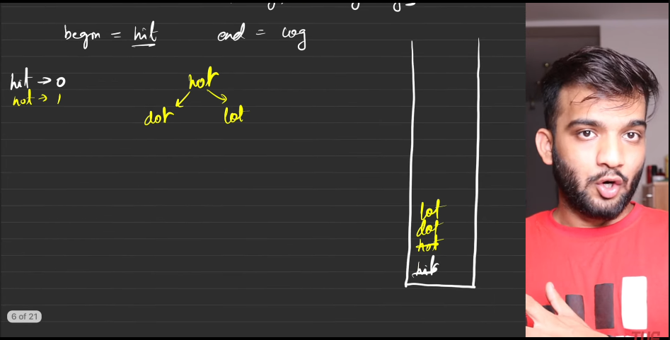
17. 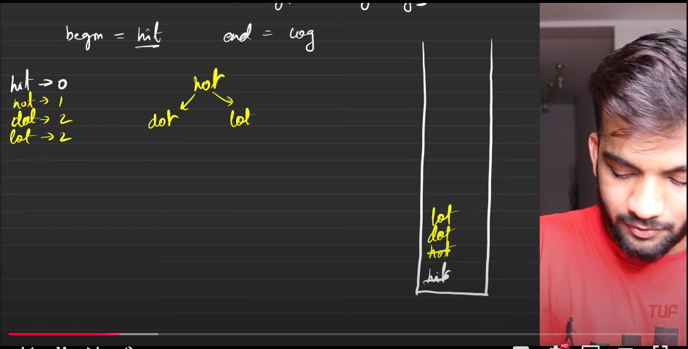
18. The words we are getting at the different levels is mentioned along with the word. word - level.
19. 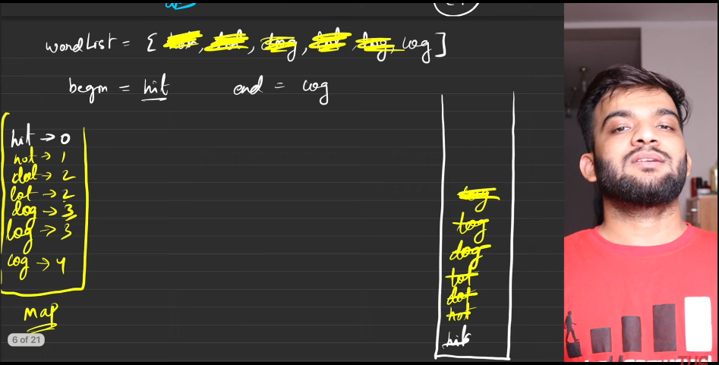
20. 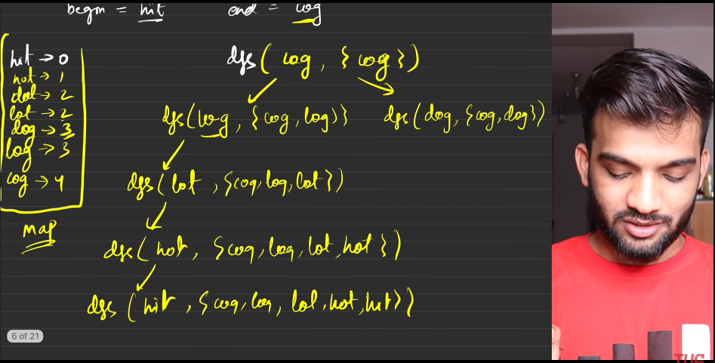
21. 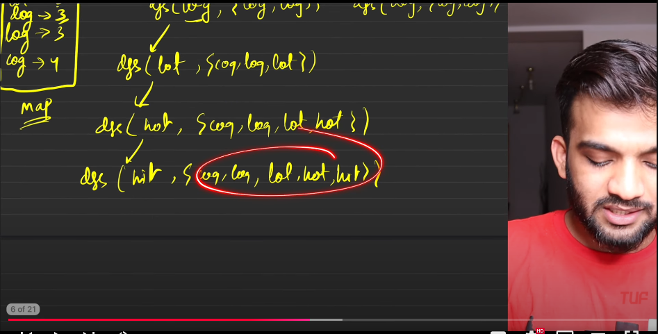
22. 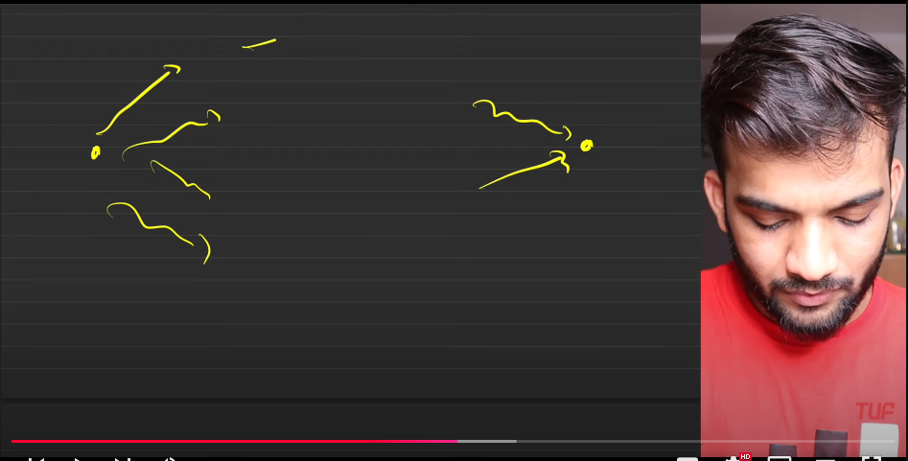
23. Consider we are moving from source to destination, there will be lot of ways to go from point to a , but there is only 2 paths to reach point b[hack]. So now backtarck by using this.
    1. **Step1**: Figure out the shortest path from word ladder one and keep the things inside the map and use that map, for further purpose.
    2. **Step 2**: 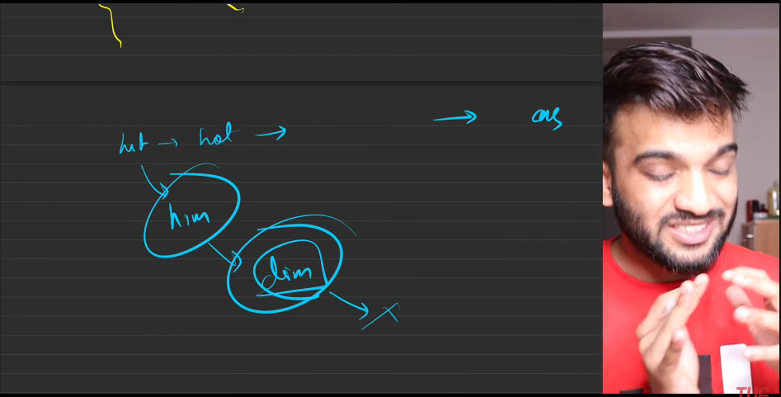
    3. if we move from the front till end, the there would be problem like we are stucking in between keeping the unncessary things in between, so need to move from back, from the source.
    4. Stop unnecesarily exploring the extra paths. This is the thing, unnecessarily takeout the useless paths.
    5. But don’t use it in interview.
    6. 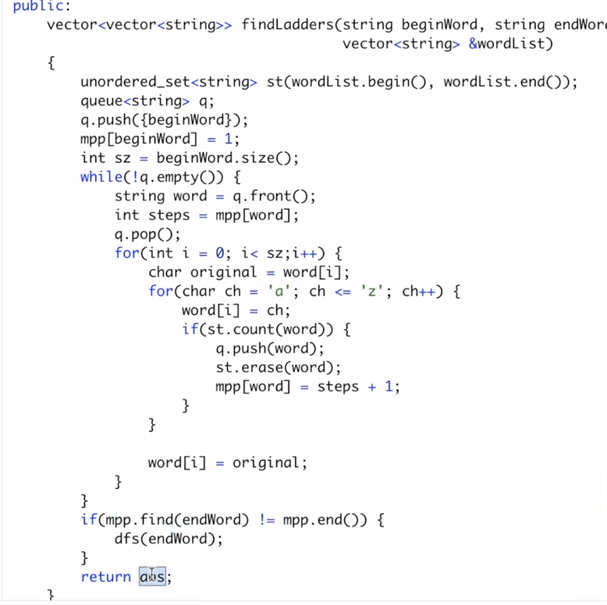
24. s,